**Lecture 1 Introduction**

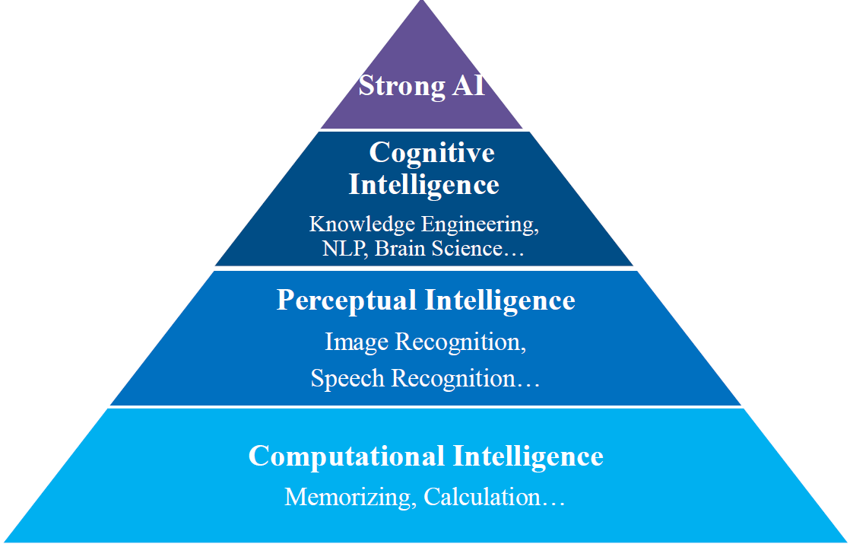

**0. KE**在人工智能中的地位:属于认知智能，在strong AI(强人工智能)和perceptual AI(感知智能)之间.

Knowledge Engineering: is a field of AI,试图在给定领域模仿⼈类专家的判断和⾏为，是创建专家系统背后的技术，以协助解决与其编程知识领域有关的问题，知识工程是指建立、维护和使用基于知识的系统所涉及的所有技术、科学和社会方面.

利用知识系统解决特定领域问题背后的所有技术；人工智能的一个重要分支

Knowledge-based systems:推理并利用知识库解决复杂问题的计算机程序.

**1. 知识图谱.**

**A. 什么是知识图谱?**KG是一个有向图G=<V,E>,V 是一组实体和字面,包括Instances:单个实体(比如南京), Concepts:概念实体(比如城市);Literals:字符串和数据类型(比如日期,高度), E 是一组带标记的有向边，每条带标记的边表示一种relation或property。

在万维网不断发展的背景下,具有代表性的知识工程技术.

**B. KG分为本体层(Schema层)和实例层.**

**Ontology/Schema:** 定义了⼀些概念(concept)以及它们之间的关系(属性、属性的定义域值域、概念之间的关系).

**Instance/Individual:** 事实/个体，具体的个体.

**Concept：**⼀个基本概念或对象类型(类)

**Entity:** 指⼀个具体的个体,也可以指⼀个概念an individual entity or a conceptual entity.

**Property/Relation:** 当这两个词同时出现，这⾥关系relation=object property连接两个实体，property=data

property连接实体和literal.

**2. 知识图谱技术概览**

**KR(Knowledge Representation)**研究如何使用计算机符号来表示人脑中知识,以及如何通过符号之间的运算模拟人脑中推理过程.基于数学逻辑的 KR $→$ 基于向量空间学习的分布式 KR

Knowledge Extraction知识抽取,Entity Linking实体连接,Knowledge Storage知识存储, KBQA (Knowledge based Question Answering, with knowledge graph,基于知识的问题解答，含知识图谱), Knowledge Reasoning知识推理(基于描述逻辑,规则,概率逻辑,表示学习.), Knowledge Fusion(知识融合)

**Lecture 2 KRR:XML,RDF,RDFS**

**0. 知识表征**就是使用计算机能够处理的表征方式来表达人类的知识:数理逻辑,产生式规则,语义网络,框架...

**1. 知识图谱表征**就是使用计算机能够处理的表示来表达知识图谱中的知识。

**2. W3C Stack:** (Definition Language是用于定义词汇表和本体的语言)

XML:用于数据交换的标记语言;一种序列化格式,表面语法,无语义(缺乏术语的含义/定义以及术语之间的明确关系);XML Schema：描述 XML 文档的结构.

RDF:对things之间relations的数据模型.

RDF Schema(RDFS):RDF的词汇定义语言.提供基本的类型系统.

OWL:表达能力更强的词汇定义语言.用于定义更复杂的本体关系.

|  |  |
| --- | --- |
| XML | HTML |
| 可扩展的标签集 | 固定的标签集 |
| 内容导向 | 展示导向 |
| 标准数据基础设施 | 无数据验证功能 |
| 允许多种输出形式 | 单一演示 |

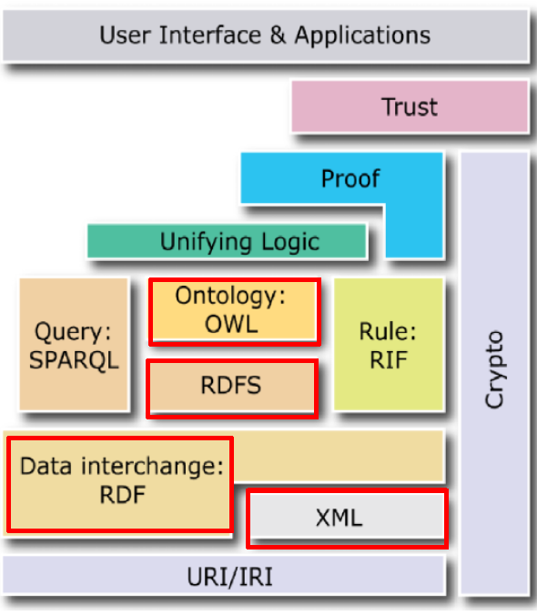

**3. XML**

**XML元素:** 描述括在匹配标签对中的对象,tags大小写敏感. 可包含文本和 / 或其他 XML 元素,可任意嵌套.空元素可以被缩写e.g. <year></year> can be written as <year/>.最外层的元素称为根元素（只有一个）

**XML属性:**<City ZIP=“210000”> Nanjing</City>中的ZIP=“210000”(name-value pair).

**XML编写指南：**A. 所有元素都必须有结束标记(配对)B. 所有元素必须干净利落地嵌套(不允许元素重叠,即交叉嵌套）。C. 所有属性值必须用引号。D. 每个文件必须有唯一首元素，即根节点。

**4. XML NameSpaces:** 提供了一种避免元素名称冲突的方法.

**The namespace** can be defined by an xmlns attribute in the start tag of an element

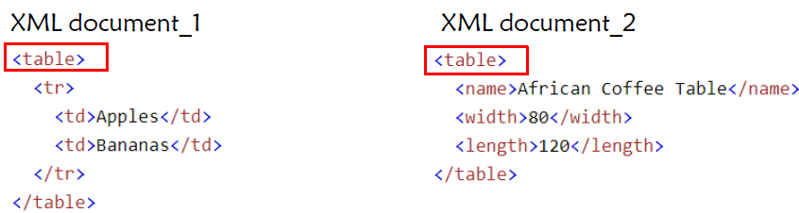

**Solution :** Adding prefixes

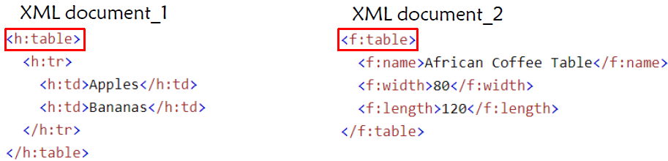

**Defining a namespace for each prefix:** use an xmlns attribute.

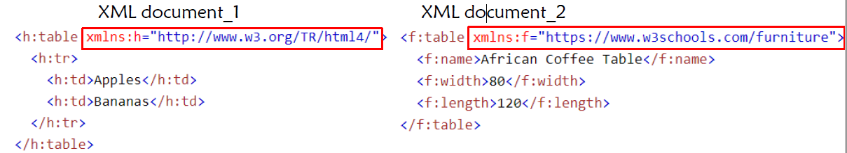

**Defining the default namespaces(与上面相比xmnls后没有:h和:f) 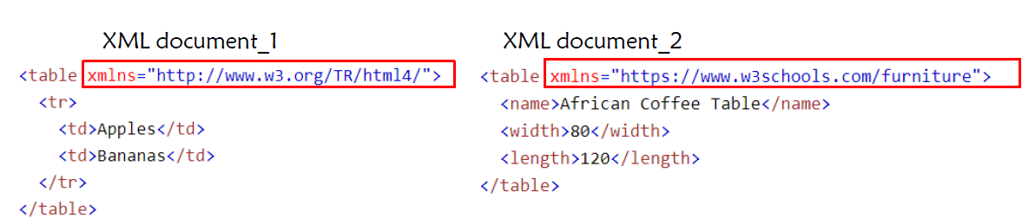 XML Namspace Syntax**

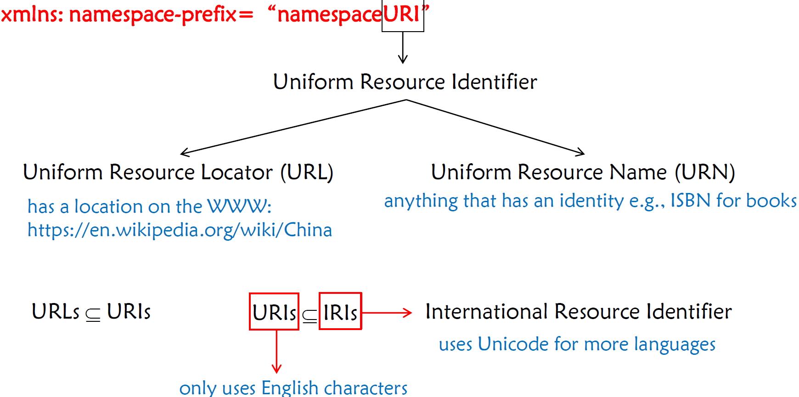

**5. XML Schema:**规定了如何正式描述 XML 文档中的元素。

**为什么我们需要XML Schema?**

在应用程序之间交换 XML 文档时，XML的自由度会造成障碍,(e.g.<author>Guilin</author>的一百种写法)

- 有必要对信息的结构达成一致，包括标记和属性的名称，以及是否需要某些子元素。

- XML Schema是W3C为此制定的一项标准。

- XML Schema本身就是用 XML 编写的。

- 根据 XML Schema验证过的 XML 文档是 “格式良好 ”和 “有效 ”的。

**XML VS. RDF**

- 合并XML的树结构较为繁琐,并且合并后的结构并不总是清晰的

- IRI 解决了术语含义(实体标识歧义性)的问题。

-Triple-based data model描述术语之间的关系或属性。

**XML Schema VS. RDF Schema(为什么已经有了XML Schema还要有RDF Schema)**

- XML Schema only defines syntax without semantics;(只定义了语法而没有语义)

- XML Schema cannot reference “things” outside the document.(不能引用文档以外的事物)

- 一个资源可能是一个以上类别的成员.

-使用 IRI 无法在语法上区分实例名和类名

- RDFS 有助于明确说明一个资源表示一个类(ex:book rdf:type rdfs:Class), 类别本身也可以按层次结构排列(ex:Textbook rdfs: subClassOf ex:Book .

ex:Book rdfs:subClassOf ex:PrintMedium . rdfs:subClassOf这个property具有传递性和反身性)

**6. RDF: @prefix rdf: <http://www.w3.org/1999/02/22-rdf-syntax-ns#> .**

语义技术和语义网的数据模型, 关于(Subject, Predicate, Object)的三元组.

**RDF知识库**：有向标注图，即知识图谱

**RDF知识库存在的问题**:. Names are ambiguous即实体标识的歧义性(同为”Boston”可能指城市\地区\组织等,自然语言名称本身无法唯一标识实体) $→$ We need unambiguous identifiers, such as IRI, URI, URL on the Web.以及关系语义的模糊性.

**QName**:在RDF 中用作长 URI（IRI）的简称(db:Boston的扩展规则)

**RDF Triple**(Statement即语句)

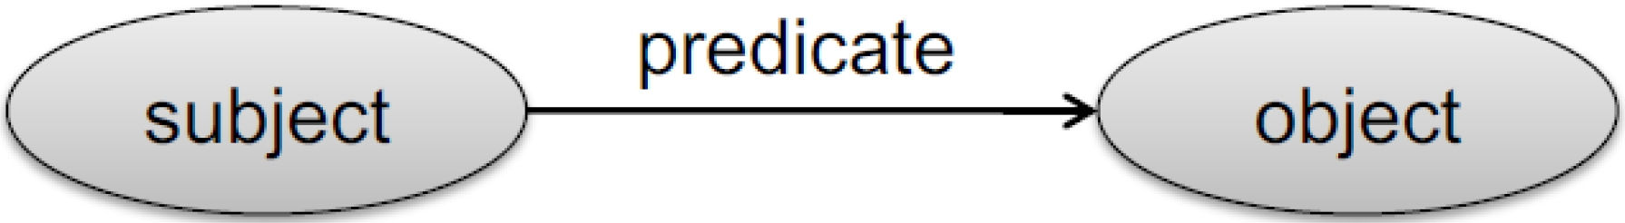

**Subjects:** Resource or blank node; **Predicates**: Resource; **Object**:Resource, literal or blanknode.

**Resources** are IRIs;

(空白节点集合,所有的IRI(命名资源)集合和所有字面量集合两两不相交)

**Literals** are: **data values**; encoded as **strings**; interpreted by **datatypes**; treated the same as **strings without datatypes**, called **plain literal(即普通字面量);**( A plain literal may have **a language tag;** Datatypes are not defined by RDF, but usually from XML Schema.)

**Typed Literals:** “Beantown”^^xsd:string,“The Bay State” ^^xsd:string.

“France”,“France”@en“France”@fr, “法国”@zh “Frankreich”@de

(“France”和”France@en”属于2个不同类型的literal,**不能同等对待**)

**Equalities for Literals:**“001”^^xsd:integer = “1”^^xsd:integer,“123.0”^^xsd:decimal = “00123”^^xsd:integer (based on datatype hierarchy)

**Plain literal and literals with language tags:**



**Blank node:** unnamed resource or complex node

**Blank node的表示**(依赖于语法):underline+colon+ID,e.g. _:xyz, _:bn

**空白节点 ID 的作用域**仅限于它所属的文档。(类似于局部变量名)

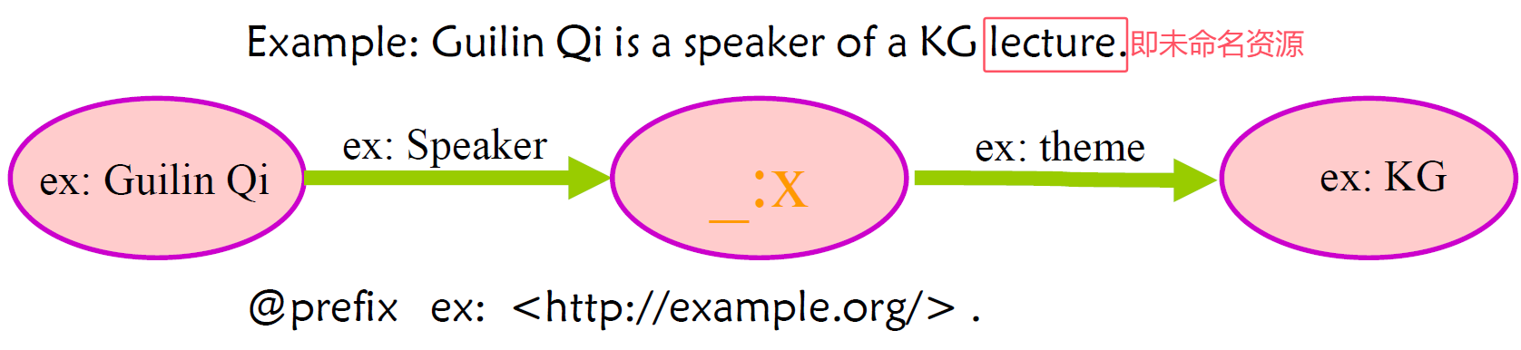

**7. RDF Syntax:**序列化格式(语法)

Turtle: 每个SPO三元组以**句号 .结尾,不要漏掉!!!** 相同主语的三元组用分号隔开,相同主谓的三元组的不同宾语用逗号隔开.

根据graph写RDF时注意Resources和Literals的表示区别,字面值需要用双引号括起来,而且不应该使用QName

需要看懂用XML表示RDF的含义,不需要会写:

属于RDF语⾔的标签带有固定的命名空间，通常缩写为“rdf”

XML声明之后是RDF⽂档的根元素：<rdf:RDF>。

The <rdf:Description> >元素包含由 rdf:about attribute.属性标识的资源描述。

**8. RDF N-ary Relations(N元关系):**将包含多个值的关系转换为标准的RDF三元组形式.

并非所有关系都是二元关系.所有 N-ary 关系都可以使用辅助节点 “编码 ”为一组二元关系，这个过程被称为 “**reification(重化)**”。

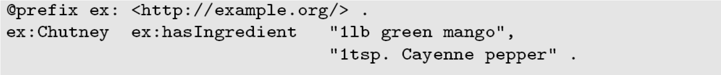

改写为

进一步改写为

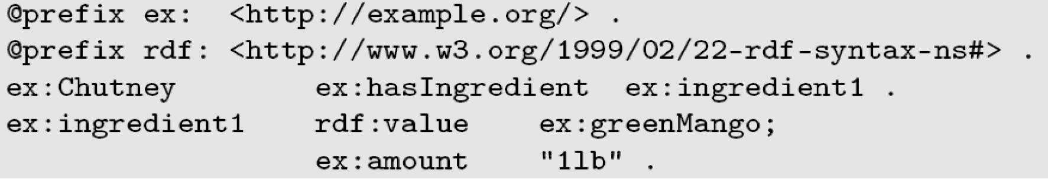

辅助节点ex:ingredient1可以用空白节点表示(unnamed resource)

**9. RDF Schema(RDFS)** **@prefix rdfs: <http://www.w3.org/2000/01/rdf-schema#> .**

为 RDF 数据提供了一个数据建模词汇表；是基本 RDF 词汇表的扩展；试图为 RDF 数据提供一致的解释；允许指定Schema知识(比如母亲应该是女性,只有人类才能写书)；(简单来说就是在RDF的基础上增加了一组固定的RDFS词汇，用于表示实体与类、类与类之间的固有关系)

描述**Class and Instance**(rdf:type)**;**

**Class Hierarchy (Taxonomy)**(e.g. rdfs:subClassOf,传递性 $→$ 进行推理,反身性 $→$ 可以导出类别等价)

**Property and Property Hierarchy**(rdfs:subPropertyOf,传递性,反身性);

**Property Restrictions**(允许说明某一属性只能存在于某一类事物之间,rdfs:domain(对主语),rdfs:range(对宾语),这里的”主语””宾语”分别都是一个concept; 数据类型也可用于添加Property Restrictions; interpreted globally and conjunctively);

**Reification:e.g.如下**

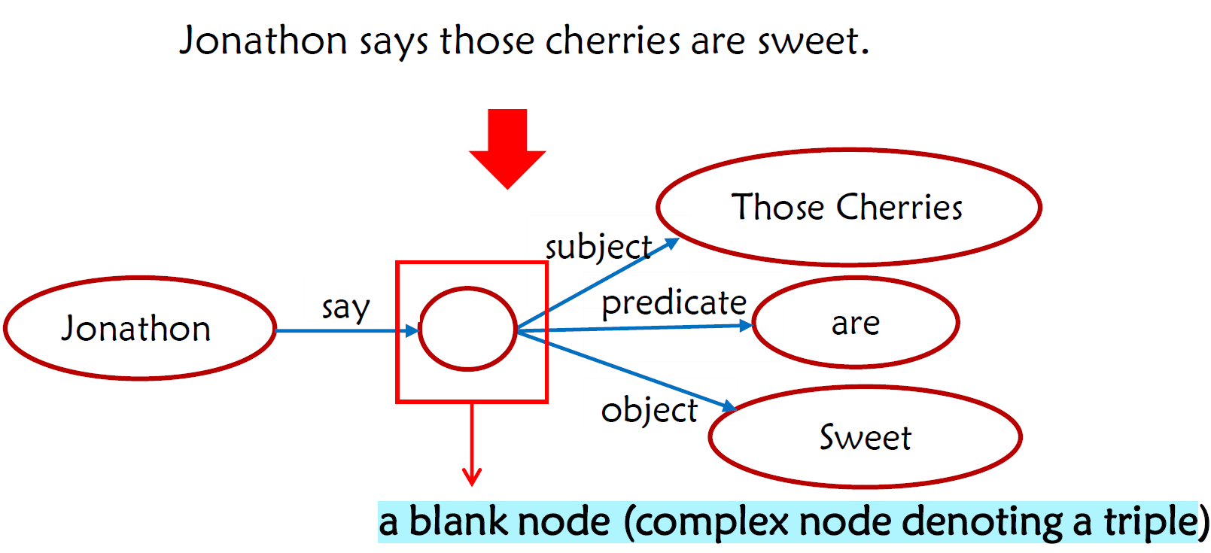

接上,

**Additional Information**(rdfs:label为任意资源分配名称（字面值）的属性; rdfs:comment, 为任意资源分配广泛注释（字面值，通常是自然语言描述）的属性; rdfs:seeAlso, rdfs:definedBy提供资源的属性，在这些资源中可以找到更多信息或主题资源的定义)

在RDFS中，我们可以表达以下语句:资源/节点是类的成员；类是其他类的子类；属性是其他属性的子属性；类是属性的域和范围。

**利用RDF(S)建模**:需要划分Schema Level和Instance Level

**基于RDFS推理**:主要利用subClassOf和subPropertyOf的”传递性”

**Lecture 3 KRR:RDFS, OWL Ontology**

**0. Problems in RDFS**

描述资源的能力并不强。在复杂的场景中，RDFS 的语义表达能力较弱，因为 RDFS 缺乏很多特性：

A. RDFS 对property的域和范围没有限制.e.g. For “Human ”, the range of “ hasChild ” should be Human.For “Elephant ”, the range of “ hasChild ” should be “ Elephant”.

B. RDFS 没有cardinity限制.e.g. The number of “ Father ” for one person should be one.One person has at most two parents . property: “ hasParent”.

C. RDFS 没有关于属性特征的描述.e.g. transitivity, symmetry, functionality, relations to other properties (inverse, equivalence)…

D. RDFS 缺乏对等价性的定义.e.g. equivalence on individuals, classes, and properties.

**1. OWL(Web Ontology Language)**

**什么是本体?** 以一个KG为例, 其中的Schema层 $≈$ Ontology. formal

, explicit specification of a shared conceptualization本体是一个共享概念化的一种形式化的显式规约 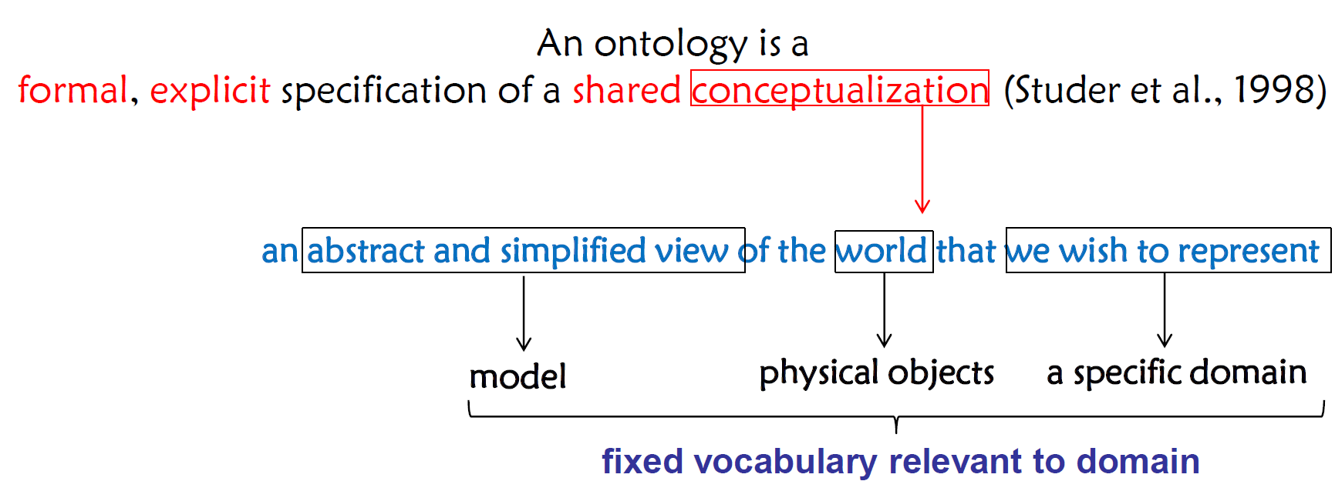

* formal, explicit: use RDF data model.
* shared: fixed vocabulary definitions(vocabulary definition language: RDFS, OWL)

**OWL: @prefix owl: <http://www.w3.org/2002/07/owl#> .**

- 在 W3C recommendation（2004 年）中引入；

- 基于 RDF 语法，使 OWL 文档易于被机器理解；

- 比 RDFS 更有表达力；

- 允许逻辑推理（基于描述逻辑）。

**2. 在Turtle语法下引入OWL的重要词汇:A.** 主要用于描述类、个体和属性之间的**等价性**@prefix exp: <http://example.org>

exp:Athlete **owl:equivalentClass** exp:SportsPlayer .

exp:obtain **owl:equivalentProperty** exp:acquire .

exp:SportsPlayerA **owl:sameAs** exp:Thomas .

B. 类之间的**不相交关系**

exp:Man **owl:disjointWith** exp:Woman .

C. 类之间的**交集关系**

exp:Mother rdf:type owl:class ;

**owl:intersectionOf** (exp:Woman exp:Parent ) .

(可以在括号里写多个类别,类别之间用空格隔开,表示同时相交于多个类别,最后还是要在括号外打句号)

D. 类之间的**并集关系**

exp:Parent rdf:type owl:class ;

**owl:unionOf** (exp:Mother exp:Father ) .

(可以在括号里写多个类别,类别之间用空格隔开,表示是多个类别的并,最后还是要在括号外打句号)

E. 类的**否定(Negation, 即补集)**

exp:ABC rdf:type owl:class ;

**owl:complementOf** exp:Meat .

F. 对Property的类型的:**对象属性(Object Property)和数据属性(Data Property)---**限制了Property的range取值

ex:friendOf rdf:type owl:ObjectProperty .

ex:age rdf:type owl:DataProperty .

G. 对**Property的性质**的描述:

**a. Transitive Property(用于推理)**. e.g. exp:ancestor rdf:type **owl:TransitiveProperty** .

**b. Functional Property(函数性)**, 表示这个Property的range对应的类别实体的数量只能为1. e.g. exp:hasMother rdf:type **owl:FunctionalProperty** .表示每个人只能有一个妈妈.

**c. Inverse Functional Property(反函数性)**: 表示这个Property的domain对应的类别实体的数量只能为1. e.g. exp:postgraduateSupervisorOf rdf:type **owl:InverseFunctionalProperty** .表示每个研究生只能有一名导师.

**e. Symmetric property:** e.g.exp:friendOf rdf:type owl:SymmetricProperty .

**f. Inverse relations between properties:** e.g. exp:ancestor owl:inverseOf exp:descendant .

H. 对Property的限制---(首先下面两个都是对属性的value的或value的数量限制)

**universal quantifier全称量词 $∀$:**对于描述的每个类的实例，每个的property的值都必须满足约束条件for each instance of the class that is being described, **every value for the property** must fulfill the constraint.

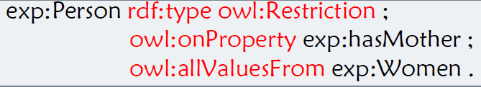

如果 exp:hasMother 的主语来自 exp:Person 类，那么宾语只能来自 exp:Women 类。

**和existential quantifier 存在量词 $∃$:**对于描述的每个类的实例，至少有一个的property的值满足约束条件for each instance of the class that is being defined, there exists **at least one value for the property** that fulfills the constraint. 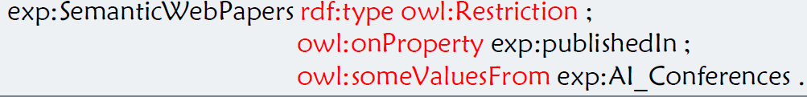

如果 exp :publishedIn 的主语来自exp:SemanticWebPapers类，那么宾语可能（至少一个）来自exp:AI_Conferences类 $→$ 部分语义网论文发表在人工智能会议上。

**和cardinalities(数量)** (owl:cardinality或owl:minCardinality)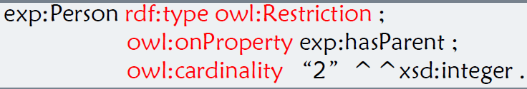

每一个人都应该有两个parents

**[Exercise]** Please write the corresponding RDF triples (in Turtle) of the following sentence: “ ChildlessPersons are the persons who are not parents ”. Note that classes “ ChildlessPerson ”, “Person”, “Parent” can be defined in the namespace <http ://semanticweb.org /> with the prefix “SW”.

_:x_0 rdf:type owl:Class ;

owl:complementOf sw:Parent .

sw:ChildlessPerson rdf:type owl:Class ;

owl:intersectionOf (sw:Person _:x_0) .

空白节点_:x_0 定义了"不是Parent的"这个概念; ChildlessPerson被定义为"Person和不是Parent的"的交集.为什么要单独定义这个空白节点_:x_0?主要是需要显式声明是一个owl:Class

**Lecture 4 KRR: Desciption Logic and Logic Reasoning**

**0.为什么要在 OWL 中添加此类定义？如何了解它们？**

-我们希望**词汇定义语言**具有以下特点：

A. 易于使用和理解

B. 正式表述

C. 足够的表达能力

D. 支持自动推理（具有适当复杂性的可判定性）

为了使用任何传统知识表征语言中的语义来支持构建 OWL---这个传统知识表征语言即为描述逻辑.

**1. 命题逻辑(Propositional Logic):** 处理命题（可真可假）和命题之间的关系，包括构建基于命题的论证。

**命题(Propostion)**是具有真值的陈述语句：要么是真（T），要么是假（F）。

**原子命题(Atomic Proposition)**

**复合命题(Compound Propostion)**涉及多个带有逻辑连接词的语句的组合:

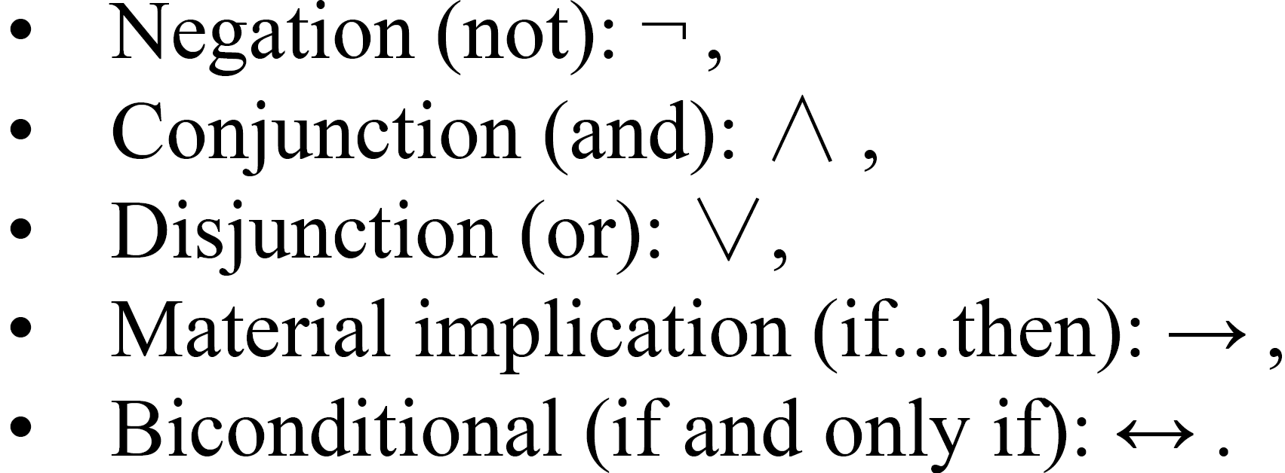

**规则推理**:Modus Ponens: $\left(p→q\right)\bigwedge{p}⟹q$

**命题逻辑存在的问题:**

-Hard to identify “individuals” (e.g., Mary, 3) 难以确定单个实体

-Can’t directly talk about properties of individuals or relations between

individuals(e.g., “Bill is tall .”) 不能直接谈论个体的属性或个体之间的关系

-Generalizations , patterns, regularities can’t easily be represented (e.g., “all

triangles have 3 sides”) 概括、模式、规律性不容易表示

**2. 一阶谓词逻辑(First Order (Predicate) Logic:)** 是一种形式语言，命题用谓词（关系）、变量和量词来表达; 包含不同种类的符号：

**Constant symbols**, which represent individuals in the world.

e.g. Mary, 3, Green.

**Function symbols**, which map individuals to **individuals**. (函数符号映射完还是表示一个个体)

e.g. fatherOf (Mary ) = John, colorOf (Sky ) = Blue

**Predicate symbols**, which map individuals to truth values.(谓词符号映射完是bool类型值)

e.g. greater(5,3)(True), green(Grass)(True), color(Grass, Green)(True).

**Variable symbols.** e.g. x, y.

**Connectives:**与命题逻辑的相同.

**Quantifiers:** 全程量词 $∀$ (universal), 存在量词 $∃$ (existential)

**3. Description Logic(描述逻辑):**

**概念:**

**- 一阶逻辑（FOL）片段**(描述逻辑是一阶谓词逻辑的一个子集,保留了FOL的部分表达能力)

**- 理想的计算特性**：可解且复杂度低于 FOL(通过限制语法和语义来获得更好的计算特性)

**- 简洁且无显式变量的语法**

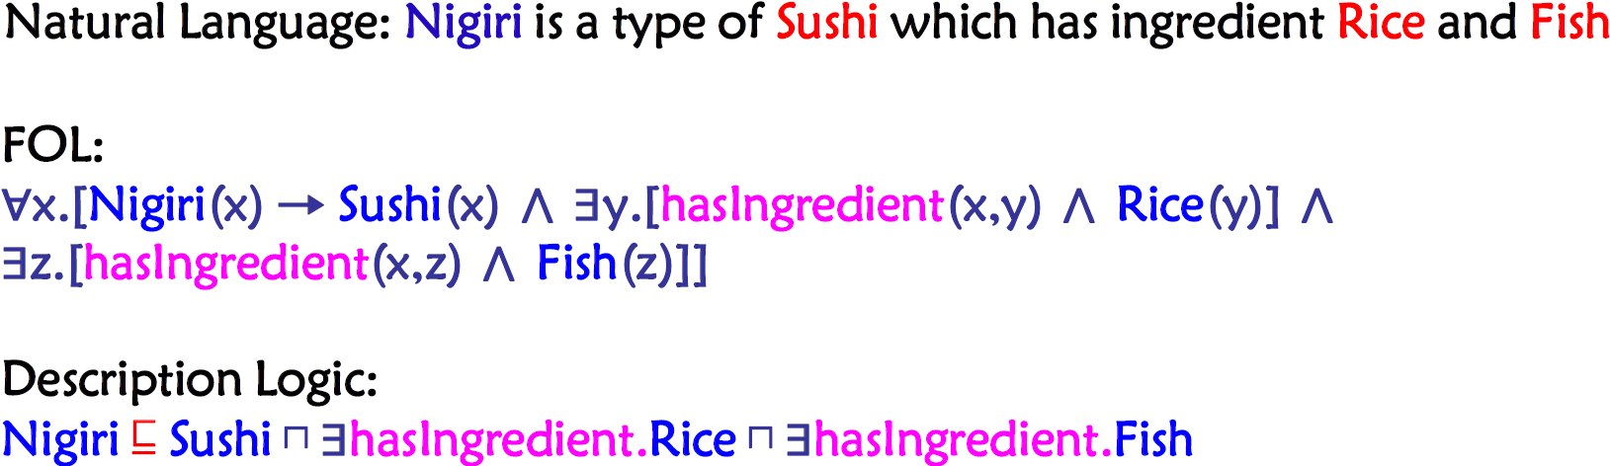

**OWL本质**上是基于描述逻辑的.

**4. Constituents of a DL Knowledge Base(DL知识库的组成部分)**

**- TBox $T$:** Ontology (aka Tbox , Terminological Box); axioms define terminology (schema)本体(又名Tbox,术语盒)其中是定义了术语的公理(对应于Schema层)

**- ABox $A$:** Ground facts (aka Abox , Assertion Box) use the terminology (data) 事实（又名 Abox , 断言盒）,使用了术语（对应于具体的data）

**ALC: 最简单的DL**



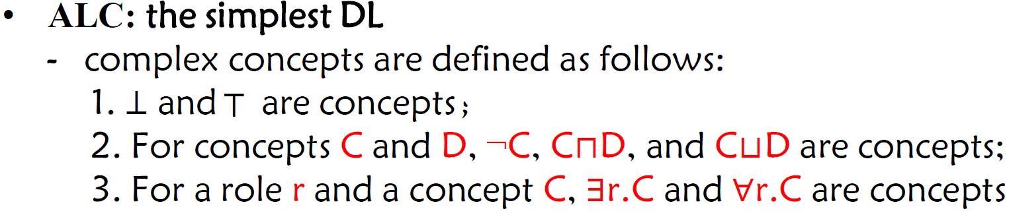

owl:allValuesFrom和owl:someValuesFrom都是作用于一个Property的range的,要求这个Property的value必须满足allValuesFrom或者someValuesFrom 它的range对应的类

**全称量词∀与存在量词∃在描述逻辑中的含义解释**: 首先给出二者基于集合的Semantics 表达，此处 $R$ 为Role， $C$ 为concept(类)

$$(∀R.C)^{I}=\{x∈Δ_{π}^{I}|\text{for every }y,(x,y)∈R^{I}implies y∈C^{I}\}$$

$$(∃R.C)^{I}=\{x∈Δ^{I}|\text{there exists }y,(x,y)∈R^{I}andy∈C^{I}\}$$

不难看出 $∀$ 与 $∃$ 均作用于 $y$ 上(如果 $x$ 和 $y$ 有关系 $R$,那么 $y$ 必须属于概念 $C$, $x$ 和某个属于概念 $C$ 的 $y$ 有关系 $R$)，可理解成对于 $∀R.C$ 与 $∃R.C$ 这两个概念在基于R 的属性值上做了某种限制。

**TBox $T$:** For concepts $C , D$, a general concept inclusion **(GCI)** axiom has the form: $C⊑D$

A. $C≡ D$ 是 $C⊑D$ and $D⊑ C$ 的缩写.

B. 一个 TBox（术语盒）由一组 GCIs 组成。

e.g. Please use a GCI to denote apple disjoints with pear.

$$Apple⊓Pear⊑⊥$$

**ABox $A$:** an ALC ABox assertion can be of one of the following forms:

A . $C\left(a\right)$, called concept assertion.

B. $r\left(a,b\right)$, called role assertion.

一个 ABox 由一组 ABox 断言组成

**5. 自然语言和描述逻辑的表达的相互转换**

**A.自然语言 $→$ 描述逻辑:**灵活地从自然语言的叙述寻于集合和集合之间的关系(交集,并集,补集,子集,等价类等),主要是对名词性词语进行分析;以及从限定词(形容词副词)找全称量词和存在量词的表达.

**B.描述逻辑 $→$ 自然语言:**从宏观上对整个句子语义进行理解.

**6. Description Logic: Interpretation**

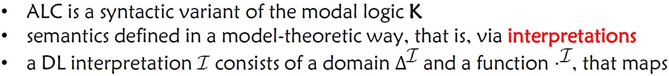

(一个DL解释模型 $I$ 包括一个论域 $Δ^{I}$ 和一个映射函数 $∙^{I}$)

映射函数的三种映射关系: 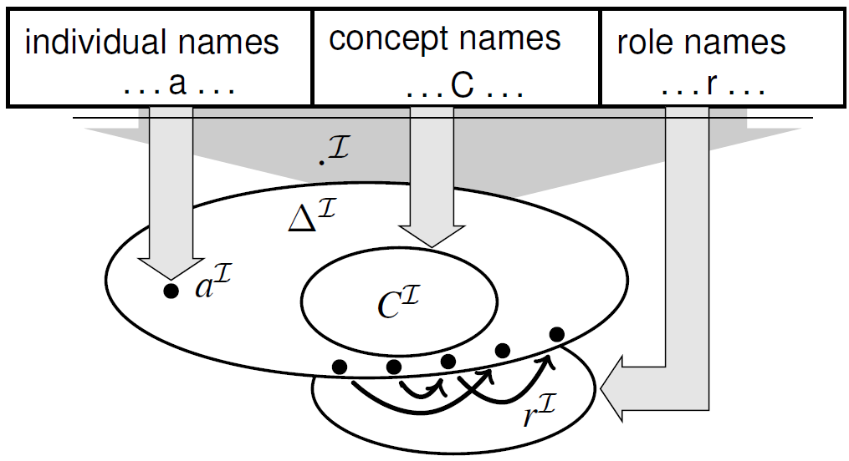

**复杂概念的Interpretations**是归纳定义的:

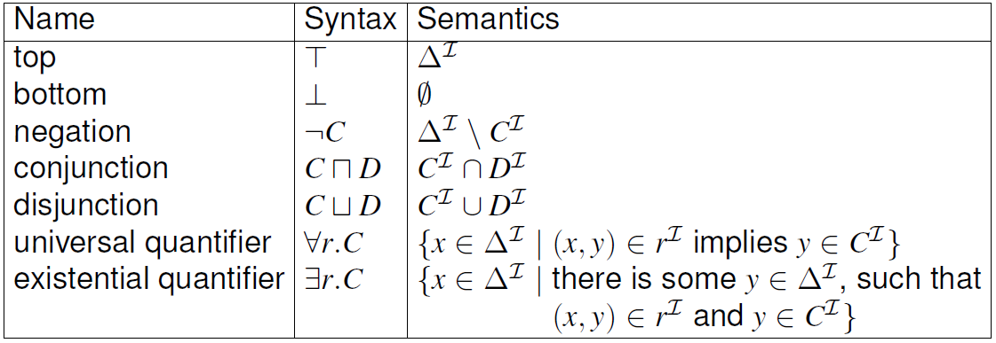

解释可以扩展到公理和断言：





**model:** 要成为一个model,解释I必须满足知识库中的所有公理和断言,即需要映射所有出现过的概念,实体和关系; 不过可以超出当前命题逻辑的表达，只要不违反条件和限制。e.g. 下面第二张图Example中的论域中定义的s

model与Interpretation的区别与联系:model一定是Interpretation,但反之则未必,Interpretation需要满足一致性和可满足性才可以成为model;model本质上是Interpretation

**从DL knowledge base到model步骤:** 给定论域 $Δ^{I}$，将所有**个体名称 $a$**映射到论域 $Δ^{I}$ 中的一个元素，将所有**概念名称 $C$**映射为论域 $Δ^{I}$ 中的一个子集(要使先前个体被映射后的元素满足原本描述逻辑中给定的概念断言),将所有**关系名 $r$**映射到论域 $Δ^{I}$ 中的元素对(要使先前被个体被映射后的元素满足原本DL中给定的角色断言).

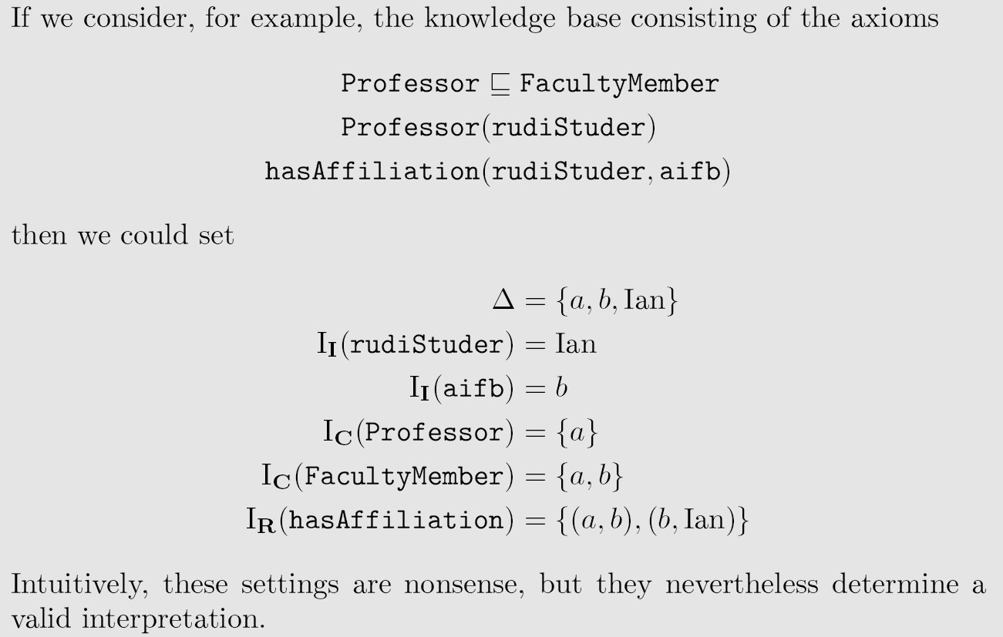

以上解释I不成为一个model的原因: 违反了Professor(rudiStuder)和hasAffiliation(rudiStuder,aifb)这两个断言

正确的版本:



**7. Description Logic: Inconsistency and Satisfiability**

- A set of axioms (knowledge base) is **satisfiable (or consistent)** if it has a model.

- It is **unsatisfiable (inconsistent)** if it does not have a model.

- Inconsistency is often caused by modeling errors.

-A knowledge base is **incoherent if a named class is equivalent to ⊥.** It usually also points to **a modeling error.**

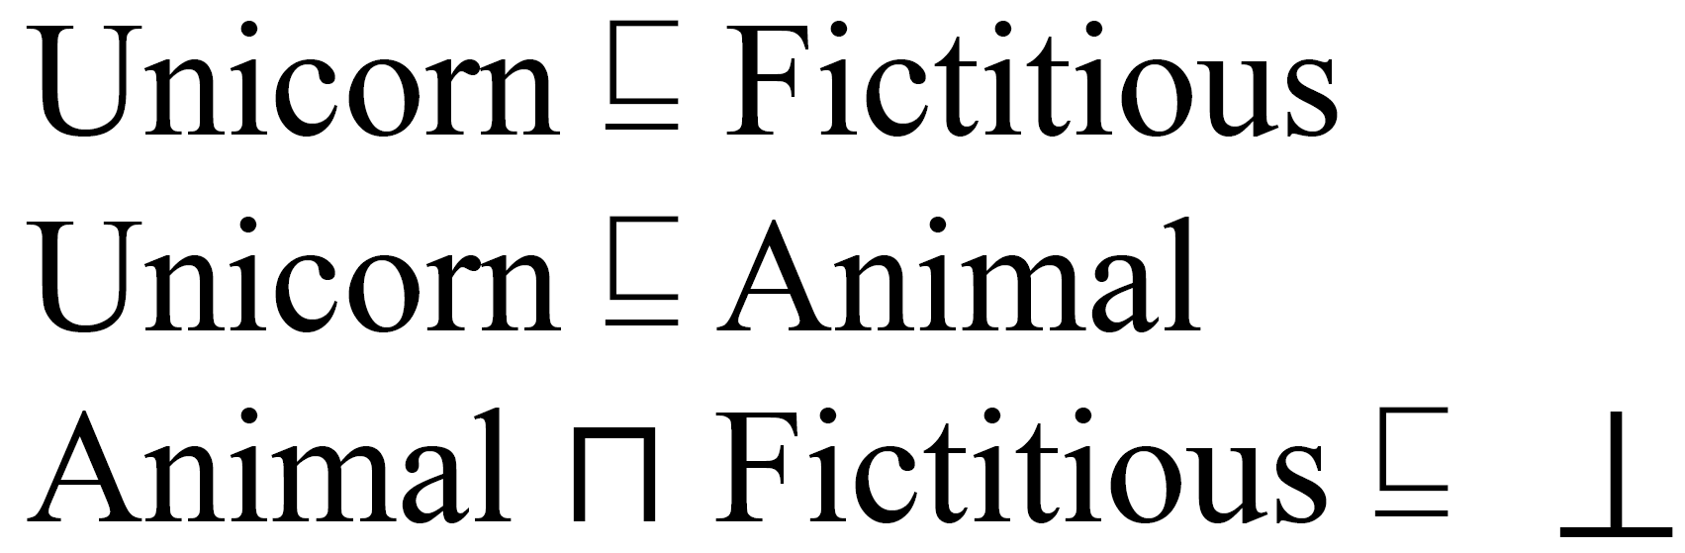

例如,在上述例子中, 由于Animals $⊓$ Fictitous $⊑ ⊥$, 所以Unicorn实际上就是等价于空集的, 这就表示在建模过程中存在了逻辑错误,需要修改类别之间的关系或者重新定义概念等,比如将Unicorn定义为MythicalAnimal而不是Animal

**8. Knowledge Graph Reasoning**

**概念:** KG Reasoning is to infer new knowledge from the given KG.

**分类:** Logical reasoning和Statistical reasoning.

**9. Logical Reasoning**

**包括:**

-**Deductive Reasoning**

-**Inductive Reasoning** attempts to support a determination of the the rule.(归纳推理,学习规则, 试图支持对规则的判定。)

-**Abductive reasoning** selects a cogent set of preconditions.(溯因推理,寻找前提)

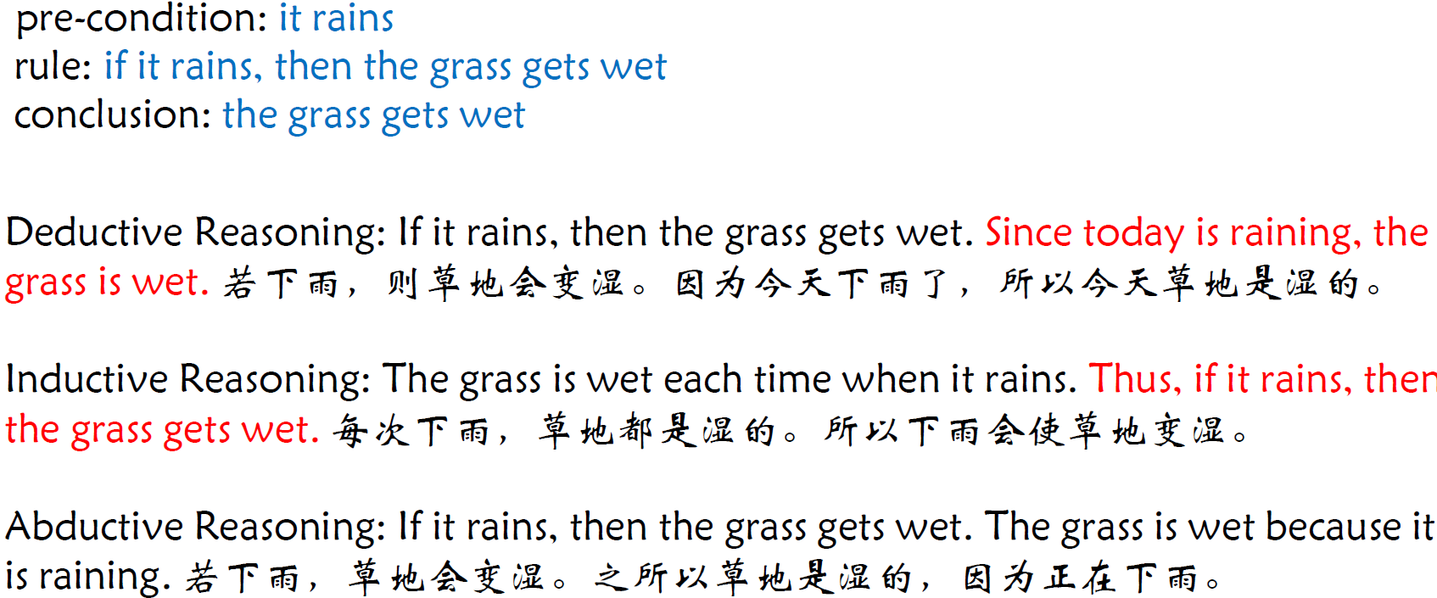

**10. Deductive Reasoning** determines whether the truth of a conclusion can be determined for that rule, based solely on the truth of the premises.(演绎推理,推导结论, 根据前提的真实性来推断结论的真实性)

**分类:**

**A. Forward reasoning(前向推理):** Forward Reasoning (forward chaining) starts with the available data and uses inference rules to extract more data until a goal is reached. 前向推理（前向链）从**可用数据**开始，利用推理规则提取**更多**数据，直至达到**目标**。(获取所有可能的结论,可能推导出不需要的结果, 计算量可能较大)

-使用前向连锁的推理引擎会搜索推理规则，直到找到已知前件（If子句）为真的推理规则。

-当找到这样的规则时，推理引擎就可以得出结论，或推断出结果（Then 子句），从而在其数据中添加新信息。

-专家系统通常采用前向链式方法。

**Materialization** is to compute **all implicit statements** by applying rules on assertions. 物化，通过将规则作用在所有assertions（断言,**Abox**）上时，把所有隐含的知识推理出来

**Classification** is to compute all implicit subclass relations by applying rules on a TBox . 分类, 通过对 **TBox** 应用规则来计算所有隐式子类关系。

**B. Backward reasoning(后向推理)** Backward reasoning (Backward chaining) is an inference method described colloquially as working backward from the goal. 后向推理（Backward chaining）是一种推理方法，俗称**从目标向后推理**。(从目标出发,寻找支持证据; 目标导向,只推导需要的结果,通常更高效)

- 它通常用于 KG 中的蕴涵检查或查询回答。

- 它使用规则以多种方式**重写查询**，如果重写后的查询与初始事实对应，则初始查询是蕴含的。

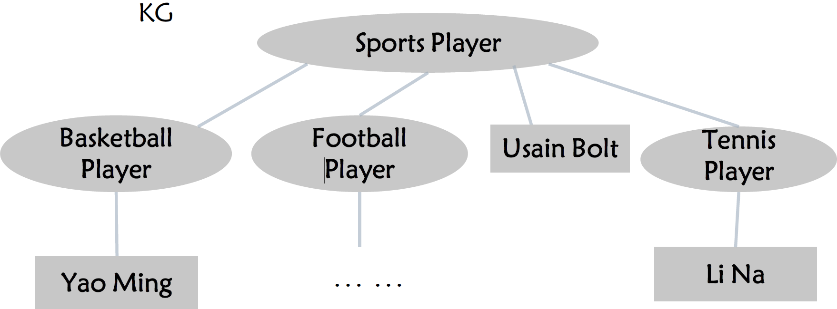

**Query**: Find all sports players with the following KG, i.e., rewrite the query

Sports_Player (x)

**Rewriting**: Basketball Player(x) $∨$ Football Player(x) $∨$ Tennis Player(x) V **Sports Player(x)**(要查到Usain Bolt这个实体,对应的查询就是需要重写成Sports Player(x), 重写查询需要重写到实体最直接属于的那个类别.)

C .

**11. Other Tasks in Logical Reasoning: Inconsistency Checking(不一致性检查)**

**Incoherent ontology(不连贯的本体):** 至少有一个不可满足概念的本体(DLKB中的公理互相矛盾,不出现实体); 没有模型的本体(DLKB不可建模,出现实体)

删除其中的公理或断言使本体一致: 首先需要注意允许操作的公理\断言数量,其次需要不重不漏,**关键在于找到存在冲突的所有语句**

[例] The following ontology is inconsistent, and remove one axiom or assertion in it to make it consistent.

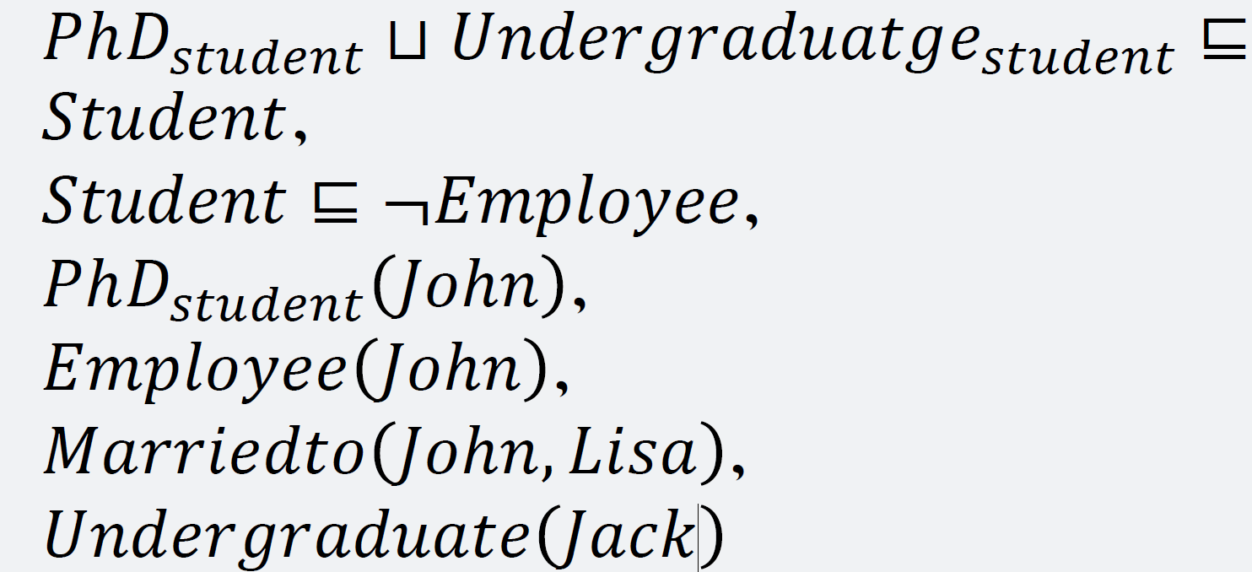

CA:W1. 删去断言Employee(John)或PhD_student(John) W2.删去公理Student $⊑ ¬$ Employee或PhD_student $⨆$ Undergraduate_student $⊑$ Student

**Leture 5 KRR Logical Reasoning and Statistical Reasoning**

**0. Logical Reasoning in Practice-Datalog**

**Datalog** is a declarative logic programming language , which is designed for knowledge base and database. Datalog has similar expressive ability with OWL. Datalog supports recursion, and rule editing (more freely) for reasoning.

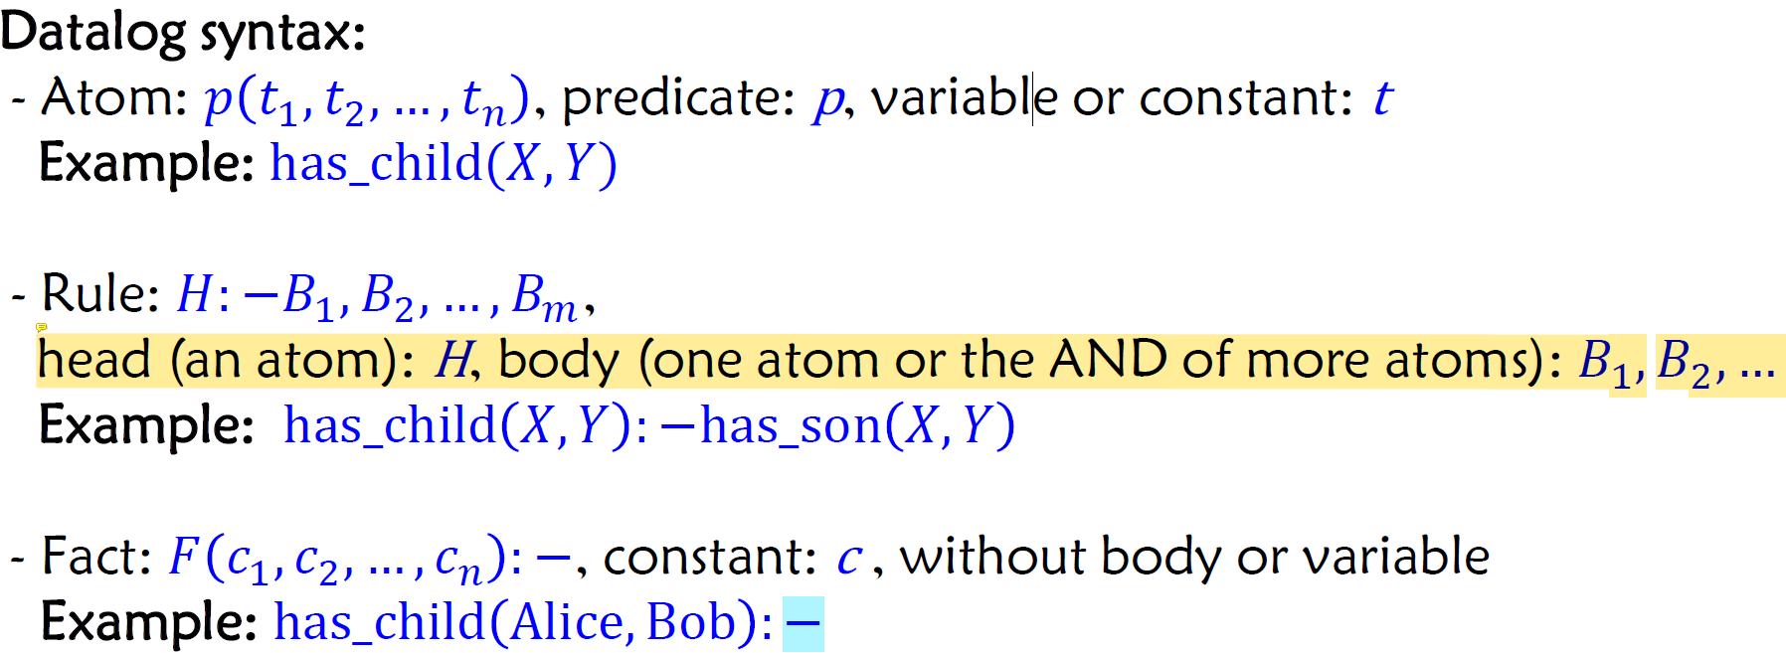

结论在前,论据在后, $H:-B_{1},B_{2},…,B_{m}$ 指可以从 $B_{1},B_{2},…,B_{m}$ 推出 $H$

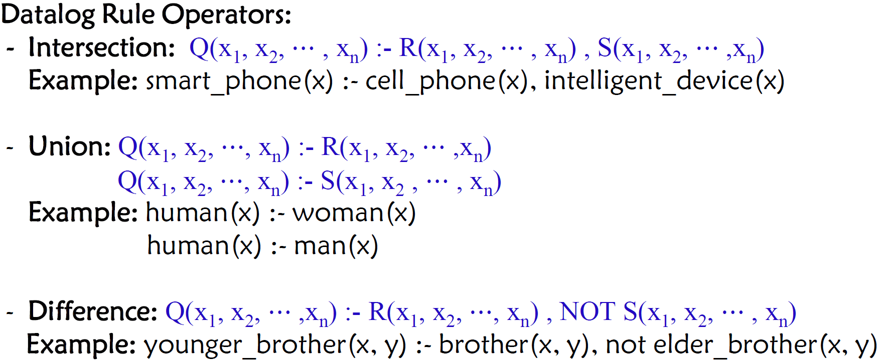

交集在一个声明中用逗号隔开,并集在两个声明中分别写, 差集用not

**1. Statistical Reasoning**

**概念:** Statistical Reasoning tries to find suitable statistical models to fit the samples and predicts the expected probabilities of the inferred knowledge. 统计推理试图找到适合样本的统计模型，并预测推断知识的预期概率。

**包括:**

-**knowledge graph embedding based reasoning**(基于知识图谱嵌入的推理)

-**inductive rule learning based reasoning**(基于归纳规则学习的推理)

-**multi hop reasoning**(多跳推理)

-,,,

**2. Knowledge Graph Embedding based Reasoning**

**任务:**

**A .Predicting the missing link:** Given $e_{1}$ and $e_{2}$,predict the relation $r$

**B . Predicting the missting entity:** Given $e_{1}$ or $e_{2}$ and relation $r$, predict the missing entity $e_{2}$ or $e_{1}$.

**C. Fact prediction:** Given a triple, predict whether it is true or false.

**Embedding: Meaning of a Word: How to encode the meaning of a word?**

**A . One-hot representation. 缺点:** a. 词表较大的时候，表示一个词的向量会造成较大的空间浪费(维度灾难) b. 无法衡量两个词之间的相似性关系（每个词向量之间都是正交的）

**B. Distributional Representation.**(分布式表示). **假设:** When a word

$w$ appears in text, its context is the set of words that appear nearby (within a fixed size window). Use many contexts of $w$ to build up a representation of $w$. $→$ word vectors(a.k.a. word embeddings) **相似度计算: $euclidean\left(u,v\right)=\sqrt{\sum_{i=1}^{n}{{\left|u_{i}-v_{i}\right|}^{2}}}$** , $cosine\left(u,v\right)=1-\frac{u∙v}{{\left|\left|u\right|\right|}_{2}×{\left|\left|v\right|\right|}_{2}}$

**Distributed Representation的优点:**

**A.** Deal with **data sparsity problem** in NLP.

**B.** Realize knowledge transfer across domains and across objects.

**C.** Provide a **unified representation** for multi unified representation for multi-task learning

**What is Representation Learning?** Objects are represented as dense , real value and low dimensional vector.

ML=Representation+Objective+Optimize

**Different ways of KG Representation:**

**A. Based on discrete symbols**(e.g. RDF, OWL, Rule Language…)

**特点:** explicit knowledge, strong logical constraints, easy to explain, not easy to expand reasoning

**B. Based on continuous vectors**(e.g. Tensor, Embedding, neural network

representation…)

**特点:** implicit knowledge, weak logic constraints, not easy to explain, closely connected to neural networks

**知识图谱嵌入的应用:** Entity Prediction(实体连接), Relation Prediction(关系预测), Recommendation System(推荐系统)

**3. TransE: Take Relation as Translation**

**思路:** For a fact ( head ,relation, tail), take the relation as a translation operator from the head to the tail **.** 对于事实（头部、关系、尾部），将关系作为从头部到尾部的**平移操作符**。

**TransE:** For each triple $< h, r, t >$, $h$ is translated to $t$ by $r$.

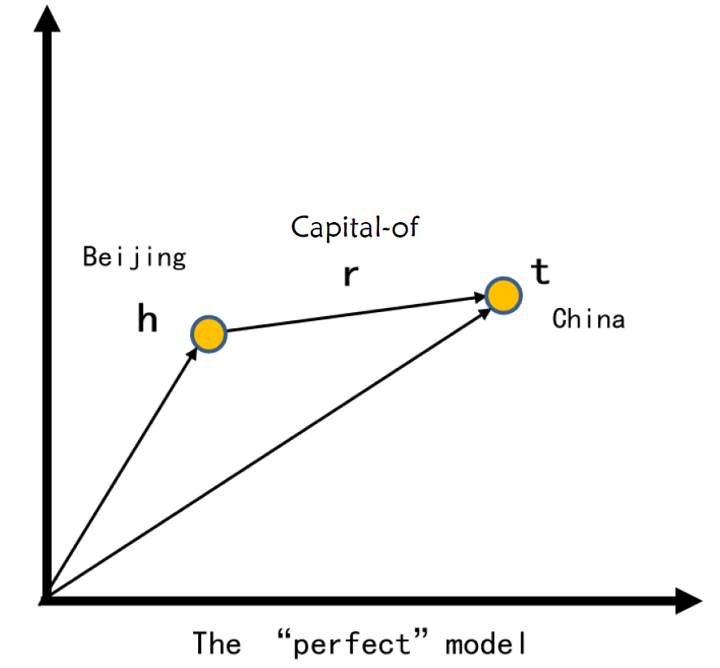

**训练TransE:**

**Energy Function**: $f\left(h,r,t,\right)={\left|h+r-t\right|}_{L_{1}\text{ or }L_{2}}$

**思路**:如果三元组 $<h,r,t,>$ 为真,那么 $h$ 和 $t$ 之间的平移距离应该更短.

- $L_{1}$**(Manhattan) distance**: $d_{1}\left(a,b\right)={\left|\left|a-b\right|\right|}_{1}=\sum_{i-1}{\left|a_{i}-b_{i}\right|}.$

- $L_{2}$**(Euclidean) distance $d_{2}\left(a,b\right)={\left|\left|a-b\right|\right|}_{2}=\sqrt{\sum_{i=1}^{d}{{\left(a_{i}-b_{i}\right)}^{2}}}$**

**如何区分True triples与False triples?**

**Loss Function**: $L=\sum_{\left(h,l,t\right)∈S}{\sum_{h^{'},l ,t^{'}∈S_{\left(h,l,t\right)}}{{\left[λ+d\left(h+l,t\right)-d\left(h^{'}+l,t^{'}\right)\right]}_{+}}}$

**其中, $S$**为真三元组集合, $S^{'}$ 为假三元组集合, $λ$ 为边界, $d\left(x\right)$ 为距离函数

**思路**: **Minimize** the distance between $( h+l )$ and $t$. **Maximize** the distance between $( h’+l )$ to a randomly sampled tail $t’$ (negative example).

**具体流程:**

**A. 输入:** Training Set $S=\{\left(h,l,t\right)\}$, entities and relationship sets $E$ and $L$, magin $λ$, embedding dim $k$.

**B.** 通过均匀分布**初始化**输入的entity和relationship.

C .对entity和relationship进行**归一化**: For each entity $e$ $(M:dimension)$:

$$e=\frac{e_{i}}{\sqrt{e_{1}^{2}+e_{2}^{2}+⋯+e_{M}^{2}}}$$

**D. Negative Sampling** and 

(采用随机梯度下降SGD)

**Evaluation protocol评估规程：**Link Prediction(e.g. (WALL-E , _ has_genre , ?))

**指标:**

**A. Mean Ranks:** the mean of those predicted ranks.

e.g. Entity 1: rank -> 50; Entity 2: rank ->100

MR = (50+100)/2 = 75

rank指的是用测试集(h,r,?)输入TransE模型，获得t',看t'在整个知识库实体的预测分数中的排名

**B. Hits@10** the proportion of correct entities ranked in the top 10.

**TransE可以建模组合关系(Composition Relation)**

**when $r_{3}=r_{1}+r_{2}$**



**TransE存在的问题:**

**A.无法建模对称关系.**

For all Symmetric (Antisymmetric) Relations, which means $\left|\left|h+r-t\right|\right|=0$ and $\left|\left|t+r-h\right|\right|=0$. Then $r = 0$ and $h = t,$ however $h$ and $t$

are two different entities and should be mapped to different locations.

**B. 无法建模一对多关系(1-to-N relations)\多对一关系(N-to-1 relations)\多对多关系(N-to-N relations)**

e.g. ( qiguilin , teacher_of , stu1), (qiguilin , teacher_of,stu2)

(qiguilin , teacher_of , stu3)…

stu1,stu2,stu3会被映射为相同的点,尽管他们不是同一个entity

**4. Variants of TransE: TransH**

**Motivations:** TransE does not do well in dealing with the relations, such as one to many, many to one, and many to many. 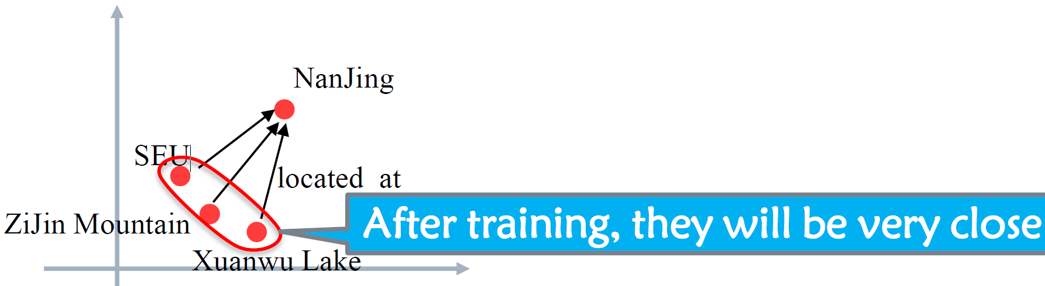

**TransH 提出:** modeling a relation as a hyperplane together with a translation operation on it. 将关系建模为超平面，并对其进行平移操作。(在由关系建模成的超平面上进行TransE)

做法: For each relation, define a hyperplane $w_{r}$ and a relation vector $d_{r}$ Then project the head entity vector $h$ and the tail entity vector $t$ onto the hyperplane $w_{r}$

$$h_{⊥}=h-w_{r}^{T}hw_{r}$$

$$t_{⊥}=t-w_{r}^{T}tw_{r}$$

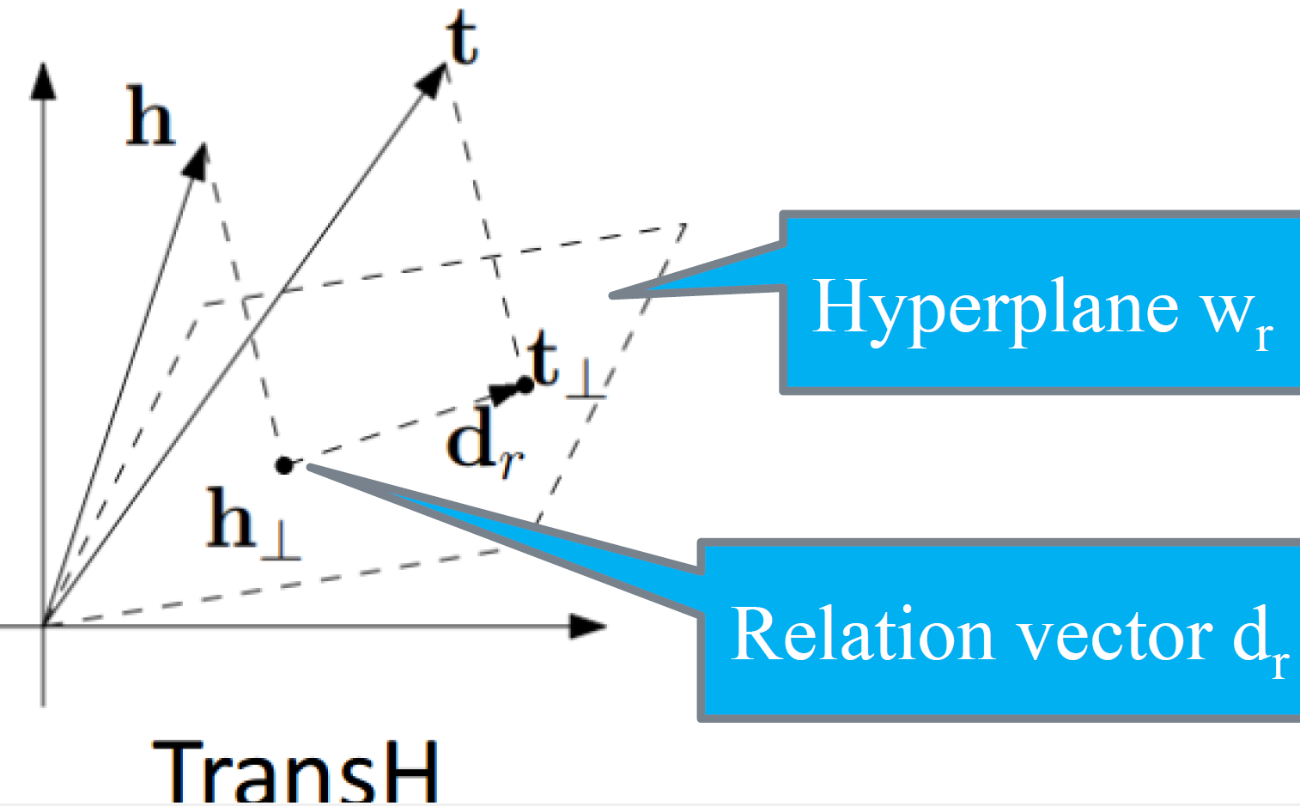

**5. Variants of TransE : TransR**

**Motivations:** Both TransE and TransH models assume that entities and relationships are **vectors in the same semantic space. 但是**In fact e

ach entity should have many aspects of semantics. A single vector space is insufficient in modeling semantics.

**TransR提出:**

-Build entity and relation embeddings **in the separate entity space and**

**relation spaces**;

-Then **projecting entities** from entity space to the corresponding relation space **and building translations** between projected entities.

$$h_{r}=hM_{r},t_{r}=tM_{r}$$

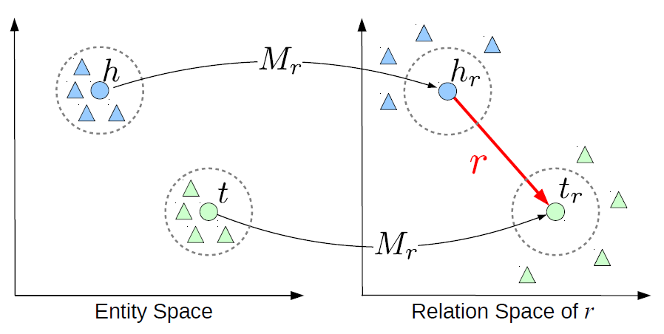

**Score(Energy) Function**(与TransE相同):

$$f_{r}(h,t)=∥h_{r}+r-t_{r}∥_{2}^{2}.$$

**Lecture 6 KGC: Knowledge Graph Construction from Structured Data (I)**

**0. Knowledge Graph Construction**

**概念**: Extracting knowledge from heterogeneous data sources to form a knowledge graph. 从异构数据源中提取知识，形成知识图谱。



**1. Basics of Relational Databases**

**Structuring data(构建数据)的方式**

**A. Tabular data表格数据**

Spreadsheets, Microsoft Excel,Google Sheets, OpenOffice Calc and Relational databases(RDB)

**B. Non-tabular data非表格数据**

**Document-orientated databases**(XML databases), **RDF triplestores(**Linked data on the Web**), Qualitative data analysis packages**(NVivo, ATLAS.ti)

**Database terms:**

- A database is a collection of data

- Data is organized into one or more tables(table name)

- Each **row** is a **record**

- Each **column** is a **field**(Set a data type for each field)

**Joins between tables: Primary Key,** **relate two tables by primary keys and foreign keys**

-Each table needs a primary key

-Choose (at least) one field that only contains **unique values,** commonly an auto-incrementing whole (integer) number

**2. RDB2RDF: Direct Mapping &RML**

**概念: RDB2RDF** is to map the content of Relational Databases to RDF. 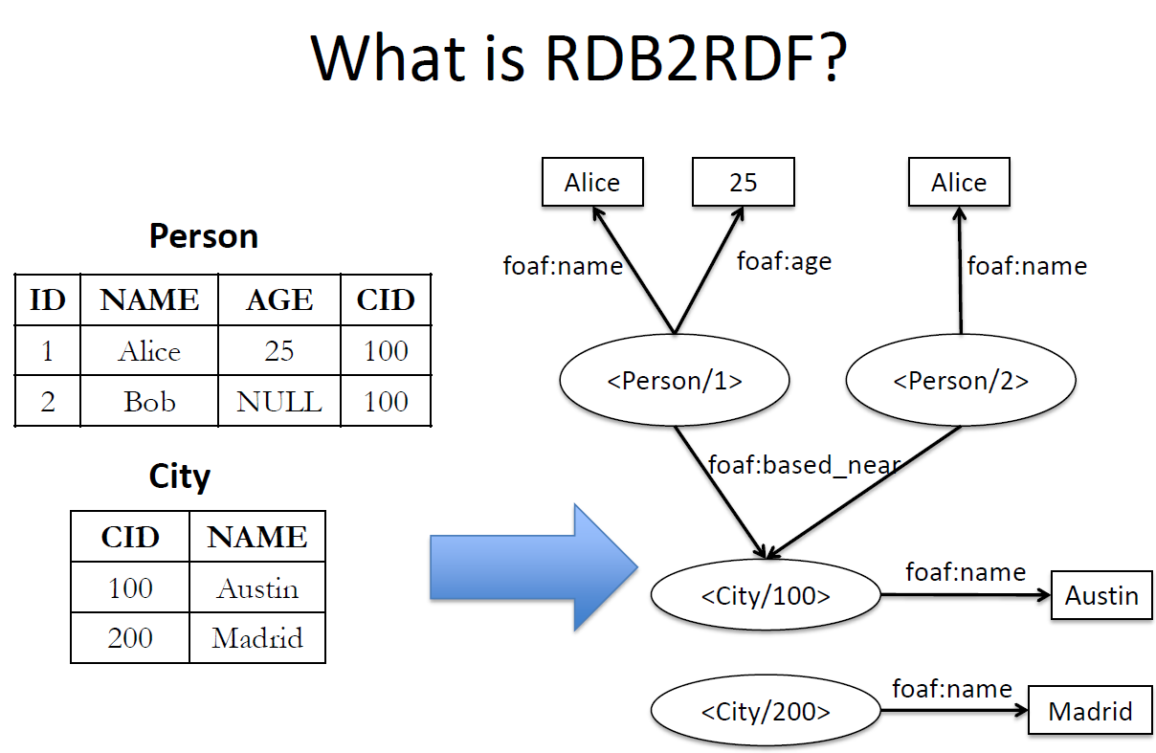

**两个W3C RDB2RDF 标准:**

**A. Direct Mapping(**A Direct Mapping of Relation Data to RDF**)**

**Default automatic mapping** of relational data to RDF.

**B.** **R2RML**

**Customizable language** to map relational data to RDF .

**3. RDB2RDF: Direct Mapping**

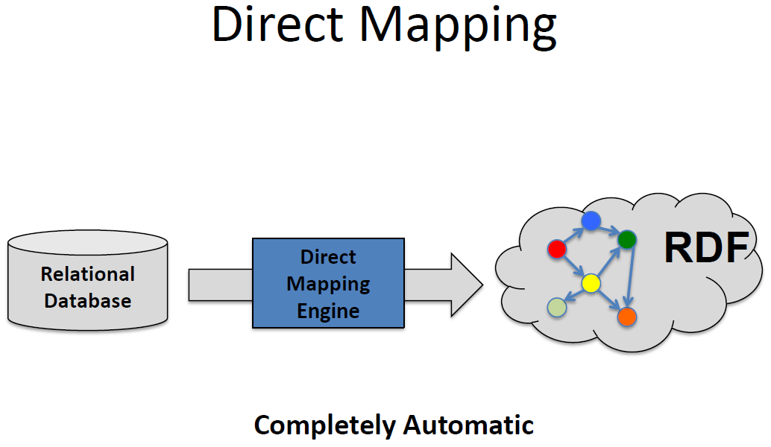

**做法:** Convert relational data into RDF, by making explicit the semantics encoded in the relational schema. 通过明确关系模式中编码的语义，将关系数据转换为 RDF。Create URIs following some simple rules:

-**table** to class

-**colomn** to property

-**row** to resource

-**cell** to literal value

-in addtion cell to IRI(if there is a **foreign key** constraint)外键关系转换为资源间的关联

**需要IRI来标识的四个方面**: (这也是从RDB转换成RDF时书写的**依据**)

首先,Base IRI for the whole graph/dataset. e.g. @base <http://foo.example/DB/> .作为所有命名资源的基础空间

**A. the resource class corresponding to a table**.表对应的类(class): 需要IRI来标识每个表对应的RDF类.

Table name $→$ Class name, e.g. People $→$ <People>

**B. the resources represented by the table rows.** 表的行对应的资源(resources)：每一行数据需要唯一的IRI

Row with PK(主键) $→$ Resource with PK. e.g. <People/ID=7>

**C. the property values of the resources corresponding to table cells**表格单元格对应的属性值(property values) 需要IRI来表示列属性

Table Column $→$ Property e.g. <People#ID>,<People#addr>

**D. the references due to foreign keys.** 外键引用(foreign keys) 需要IRI来表示表间(类间)的关联关系

Table cells: what if NULL?

Foreign key reference $→$ additional property e.g. <People#ref-addr>

Example:



转换成: (对应于前面提到的需要IRI表示的ABCD四句话)

@base <http://foo.example/DB/> .

@prefix rdf: <http://www.w3.org/1999/02/22-rdf-syntax-ns#>.

<People/ID=7> rdf:type <People> .

<People/ID=7> <People#ID> "7" .

<People/ID=7> <People#fname> "Bob" .

<People/ID=7> <People#addr> "18" .

**<People/ID=7> <People#ref-addr> <Addresses/ID=18> .**

**(**把所有column变成属性用RDF描述完之后,再描述关联的外键,注意在原来的列名addr前**加上前缀’ref-**’**)**

<People/ID=8> rdf:type <People> .

<People/ID=8> <People#ID> "8" .

<People/ID=8> <People#fname> "Sue" .

<Addresses/ID=18> rdf:type <Addresses> .

<Addresses/ID=18> <Addresses#ID> "18" .

<Addresses/ID=18> <Addresses#city> "Cambridge" .

<Addresses/ID=18> <Addresses#state> "MA" .

**4. RDB2RDF: R2RML**



**概念:** R2RML is a language for specifying mappings from relational to RDF data. R2RML 是一种**语言**，用于指定从关系数据到 RDF 数据的映射。

A mapping takes as **input** a logical table, i.e.

**A. a database table**(即直接使用物理表)

**B. a database view** (a virtual table collecting data from relational tables)

**C. an SQL query** (called an “R2RML view” because it is like an SQL view

but does not modify the database)

特点: 可以处理多个输入;可以生成多个输出;可以表达自定义映射(通过使用外部的ontology vocabularies)从RDB到RDF

**A logical table is mapped to a set of triples by a rule called triples map.** **逻辑表通过名为 "三元映射 "的规则映射为一组三元组。**

**Triples map**(三元映射):

**三个组成部分:**

**A. the input logical table(**What is being mapped?数据来源**)**

**B. a subject map(**How to generate the Subject?定义RDF主体**)**

**C. several predicate-object maps** (combining predicate and object maps).(How to generate the Predicate and Object?)

**Example**:

**Direct Mapping as R2RML:**

解读:

A. 逻辑表定义rr:logicalTable [ rr:tableName "Person" ];

指定使用Person表作为数据源

B. 主语映射:

rr:subjectMap [

rr:template "http://www.ex.com/Person/ID={ID}";

rr:class <http://www.ex.com/Person>

];

定义如何生成RDF主体,使用ID列创建URI模版, 指定类型为Person

C. 谓词-宾语映射:

rr:predicateObjectMap [

rr:predicate <http://www.ex.com/Person#NAME>;---Predicate的URI

rr:objectMap [ rr:column "NAME" ]---Object的Literal

];

定义属性(predicate)和值(object)的映射,将NAME列映射为属性值.

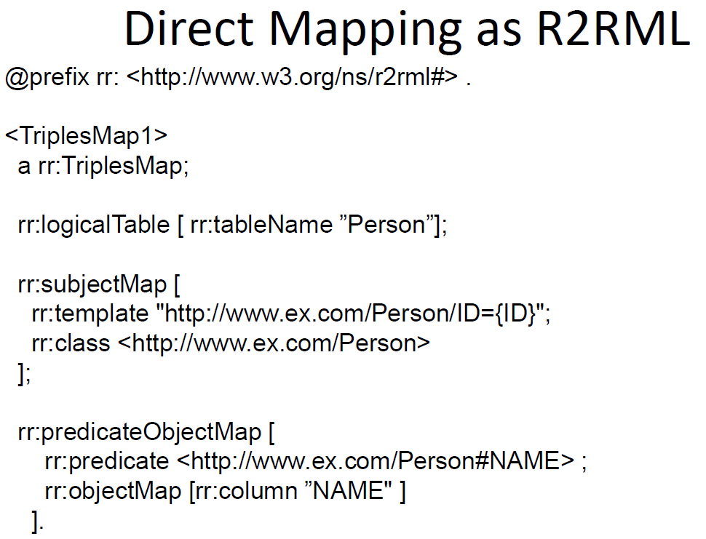

**Customized R2RML:**

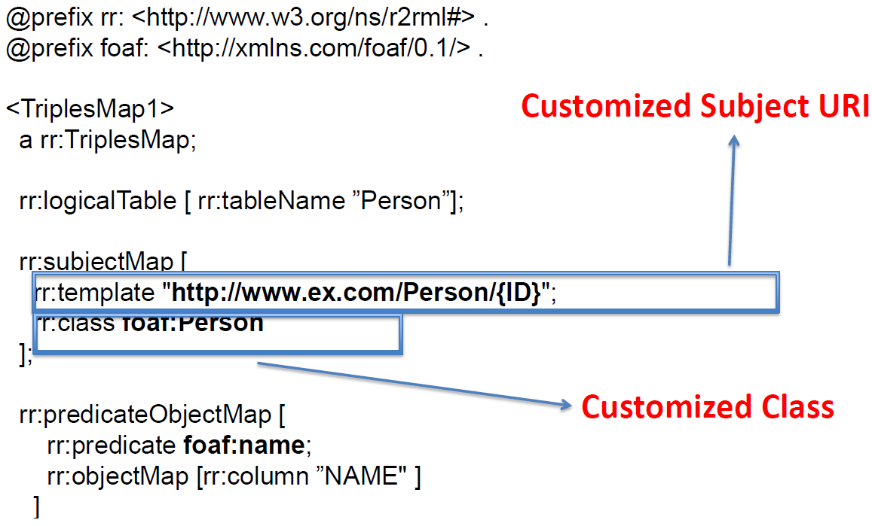

**5. R2RML其他示例**

**Relational tables:**

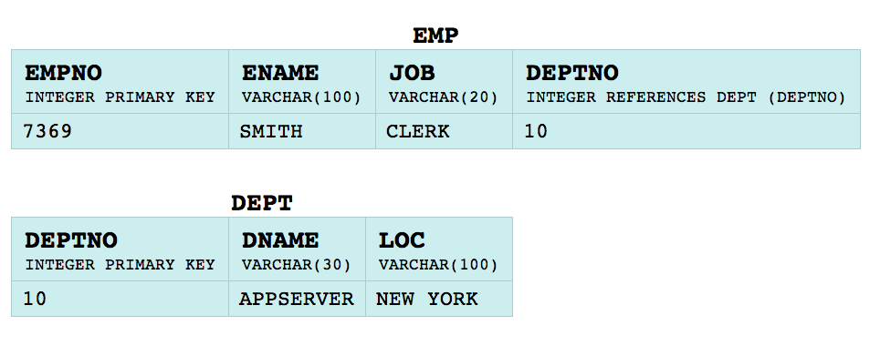

**Set of RDF triples:**

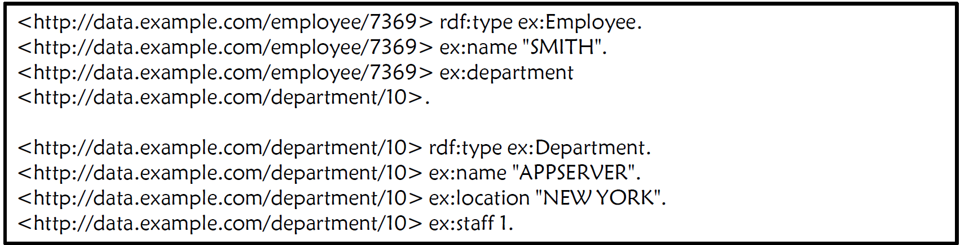

**前两行对应的R2RML**

@prefix rr: <http://www.w3.org/ns/r2rml#>.

@prefix ex: <http://example.com/ns#>.

<#TriplesMap1>

rr:logicalTable [ rr:tableName "EMP" ];

rr:subjectMap [

rr:template "http://data.example.com/employee/{EMPNO}";

rr:class ex:Employee;

];

rr:predicateObjectMap [

rr:predicate ex:name;

rr:objectMap [ rr:column "ENAME" ];

].

**最后四行对应的R2RML:**

<#TriplesMap2>

rr:logicalTable <#DeptTableView>;

rr:subjectMap [

rr:template "http://data.example.com/department/{DEPTNO}";

rr:class ex:Department;

];

rr:predicateObjectMap [

rr:predicate ex:name;

rr:objectMap [ rr:column "DNAME" ];

];

rr:predicateObjectMap [

rr:predicate ex:location;

rr:objectMap [ rr:column "LOC" ];

];

rr:predicateObjectMap [

rr:predicate ex:staff;

rr:objectMap [ rr:column "STAFF" ];

].

**中间两行定义的R2RML:**

<#TriplesMap1>

rr:predicateObjectMap [

rr:predicate ex:department;

rr:objectMap [

rr:parentTriplesMap <#TriplesMap2>;**(连接了两个逻辑表)**

rr:joinCondition [

rr:child "DEPTNO";

rr:parent "DEPTNO";

];

];

].

-child=referencing map; parent=referenced map(被引用的表,以外键作为主键的表)

-Object map retrieves subject from parent triples map by joining along a foreign key relationship对象映射通过沿外键关系连接，从父三元映射中检索主题

-它连接

- 逻辑表的当前行

- <#TriplesMap1>的逻辑表中满足连接条件的行

的逻辑表中满足连接条件的

定义视图(不考察)

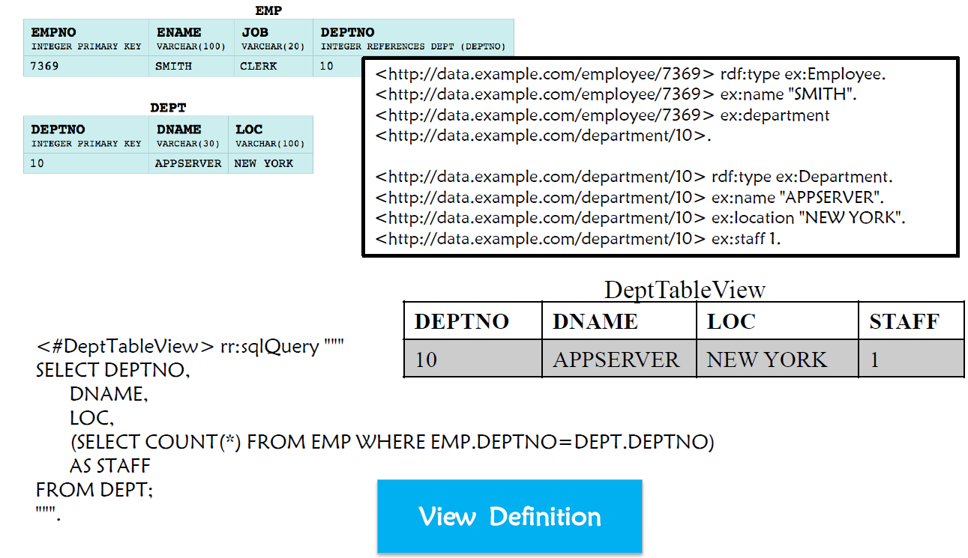

映射到视图.

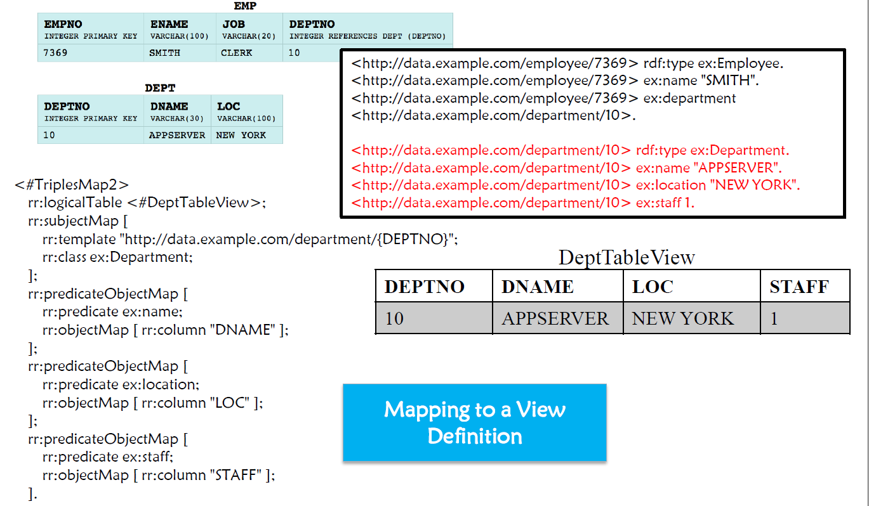

**Lecture 7 KGC: Knowledge Graph Construction from Structured Data (II)**

**0. Triple Extraction from Relational Web Tables**

**Relation Table:**

**定义:** A relational table describes a set of entities in the core column(s) along with their attributes in the remaining columns.

**Steps of Triple Extraction:**

**A . Entity Linking:** Mention to Entity**(最关键的步骤)**

**B . Column Typing**: Column to Class (i.e., Type)

**C . Relation Extraction:** Semantic Association between Columns to Relation

**1. Entity Linking:** Mention to Entity

**What is Entity Linking(EL) in Web Tables?** Mapping the **string mentions** in **table cells** to their referent entities in a given **knowledge base (KB**).

**Detailed Steps of Entity Linking(Assumption:** strings in a cell are a mention**):**

**A. Candidate Generation候选生成:** Identifying candidate referent entities of each string mention in table cells when given a knowledge base. 在给定知识库的情况下，识别表格单元中提及的每个字符串的候选参照实体。

**基于字典的方法(Dictionary-based method):**

-collecting all ( string, entity ) pairs from anchor texts, redirect pages, and

disambiguation pages in Wikipedia; -从锚文本、重定向页面中收集所有 ( 字符串、实体 ) 对，以及维基百科中的消歧义页面；

-ranking based on co-occurrence frequency. 根据共同出现频率进行排序。

**基于字符串相似度的方法(String similarity based method):**

- Computing string similarities between mentions and entities

**- Edit distance: Levenshtein distance**

(两个词之间的Levenshtein距离是将一个词变成另一个词所需的最小单字符编辑（插入、删除或替换）数量) Example: “wtx $→$ yty ”, LD=2.“wtx $→$ yt ”, LD=2

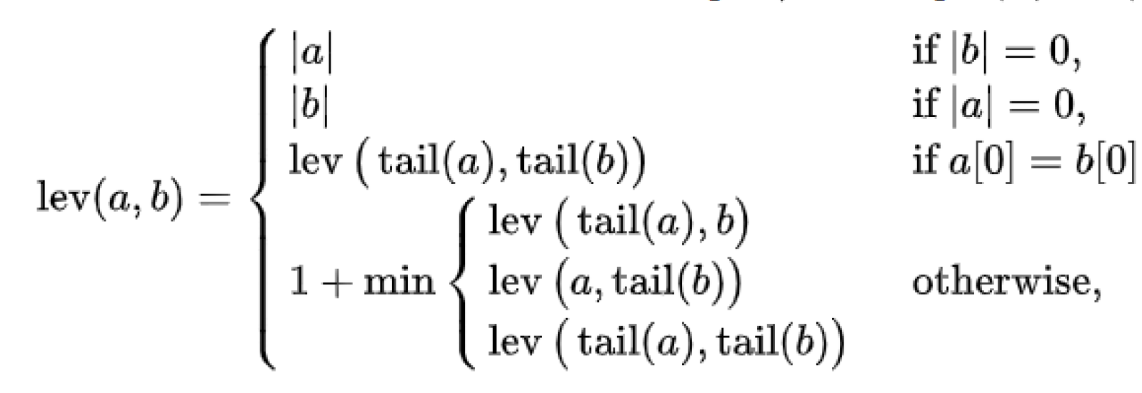

其中, “tail” of some string $x$ is a string of all but the first character of $x$, and $x\left[n\right]$ is the $n$ th character of the string $x$, counting from 0.

Note that the first element in the minimum corresponds to deletion(from $a$

to $b$), the second to insertion and the third to replacement,通常用动态规划解决

-**Jaccard similarity**

Jaccard similarity J(A,B) measures the similarity between finite sample set A and B

$$J(A,B)=\frac{|A∩B|}{|A∪B|}$$

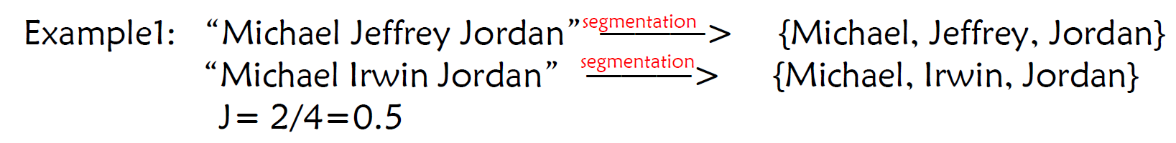

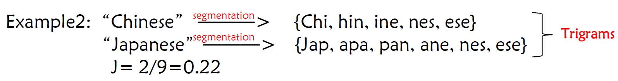

**基于同义词的方法(Synonym based method)**

**-**Combine with the dictionary based method or string similarity based method

-Use a knowledge graph containing rich synonym information.

With the above methods**, Top K candidate referent entities for each**

**mention can be obtained**.

**B. Entity Disambiguation 实体消歧:** Choosing only one entity from the candidate set as the referent entity of each string mention mention. 只从候选集中选择一个实体作为每个字符串提及的参照实体。

**为什么在实体连接的时候要拆成候选生成和实体消歧两个步骤而不是只有实体消歧这一个步骤?** 通过候选生成（简单的方法）筛掉明显不可能的实体，再通过实体消歧（比较复杂的方法）进行比对，提高效率

**分类:**

**a. Local Disambiguation**

Only use the contextual information of the given mention and target entity

for disambiguation without considering the effects of other referent entities

in the same table仅使用**给定提及实体和目标实体的上下文信息**进行消歧，而**不考虑同表中其他参照实体**的影响(主要是利用贝叶斯定理,先验和后验)

**Local Disambiguation: A generative model**

The classic generative model is originally proposed to entity linking in text, but it can be applied to Web tables. 经典的生成模型最初是针对文本中的实体链接提出的，但也可以应用于Web表格。

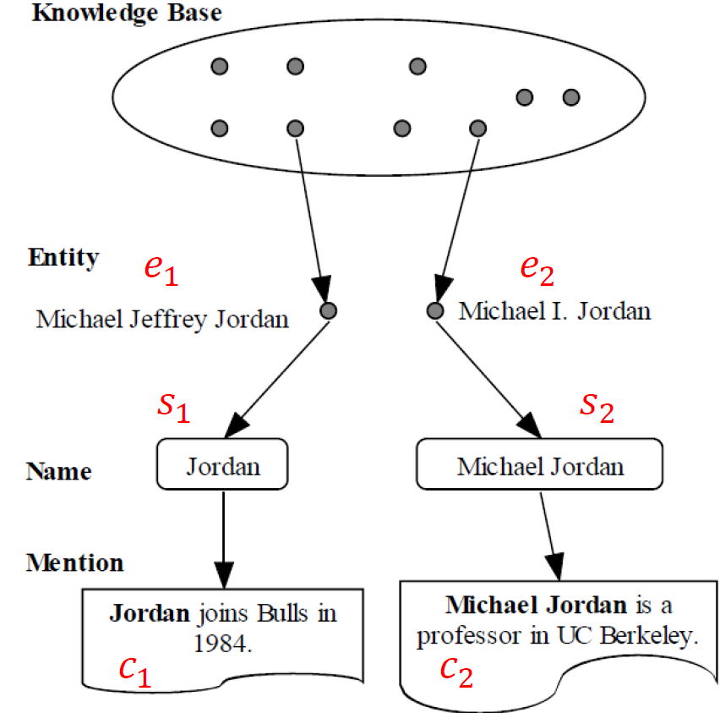

The **generative process for text: three steps:**

I. Choose the referent **entity $e$** from the KB with $P\left(e\right)$, e.g. “Michael Jeffrey Jordan”

II. Choose a **name $s$** with $P\left(s | e\right)$, e.g. “Jordan”.

III. Choose a **context $c$** with $P\left(c | e\right)$, e.g. “joins Bulls in 1984”

将第三步应用到Web表格中: 将文本中的实体上下文替换为 Web 表格中的实体上下文(实体在Web表格中的上下文表示为这个实体所在的行和列)

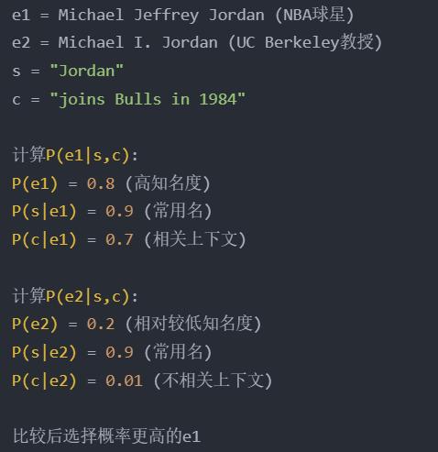

Based on the above generative story, the probability of a name mention $m$ (its context is $c$ and its name is $s$) referring to a specific entity $e$ can be expressed as assume that $s$ and $c$ are independent given $e$

$$P\left(m,e\right)=P\left(s,c,e\right)=P\left(e\right)P\left(s | e\right)P\left(c | e\right)$$

where

$P\left(e\right)$ corresponds to the **popularity knowledge**,

$P\left(s | e\right)$ corresponds to the **name knowledge** , and

$P\left(c | e\right)$ corresponds to the **context knowledge**.

Given a name mention $m$, to perform entity disambiguation, we need to find the entity $e$ which maximizes the probability $P\left(e | m\right)$.

$$e=arg⁡\max_{e} \frac{P(m,e)}{P(m)}=arg⁡\max_{e} P(e)P(s|e)P(c|e)$$

Thus, we model the popularity knowledge as

$$P\left(e\right)=\frac{count\left(e\right)+1}{N+\left|M\right|}$$

where $count(e)$ is the count of the name mentions whose referent entities

are $e$ in the training data, $N$ is the number of all entities, and $|M|$ is the total name mention size.

**训练数据**:

- a set of annotated name mentions $M=\{m_{1},m_{2},...,m_{n}\}$, each $m$ is a

triple $m=\{s,e,c\}$

**Web Table Features:** 单一表格特征（TS）指的是单个单元格中的值，而多个特征则结合了来自多个单元格的值（TM）。

**b. Global (Collective) Disambiguation:A Graph Model**

Leverage the semantic associations between candidate referent entities to jointly disambiguate all entities for the mentions in a table. 利用候选参照实体之间的语义关联，共同对**表中提及的所有实体**进行消歧。

**Why global disambiguation works**? Suppose we have three mentions which are needed to perform entity linking .



**I .**Building an **Entity Disambiguation Graph** for each given table. 为每个给定的表格构建实体消歧图。Each graph consists of:

**Mention Nodes, Entity Nodes**

**Mention-Entity Edges**: undirected edges between mentions and its candidate referent entities提及其候选参照实体之间的无向边 $→$

Mention Entity Semantic Relatedness

**Entity-Entity Edges**: undirected edges between entities实体间的无定向边. $→$ Entity Entity Semantic Relatedness

在构建的实体消歧图中，每个节点或边都有一个**概率**

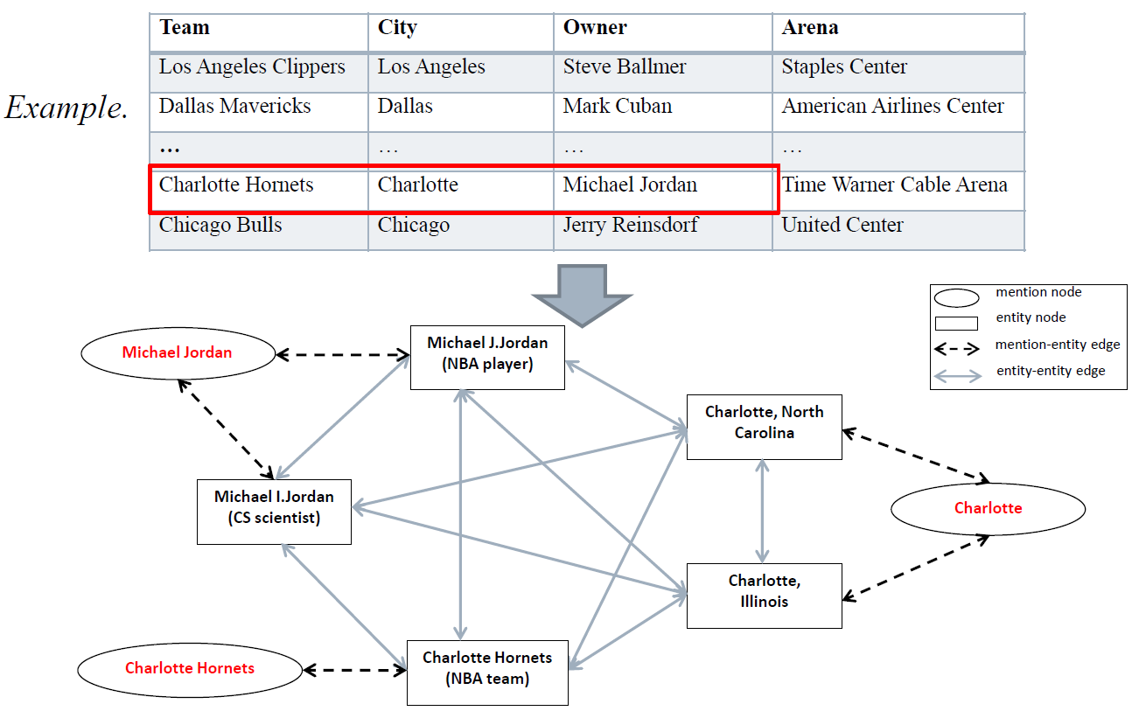

**II.** Computing EL Impact Factors. 计算 EL 影响因子。

两种EL影响因子:

**1)** **importance** of each mention;

**2) semantic relatedness** between different nodes.

**Mention Entity Semantic Relatedness:**

**Two features** are used to measure Mention Entity Semantic Relatedness

$SR_{me}\left(m,e\right)$ between the given mention $m$ and entity $e$:

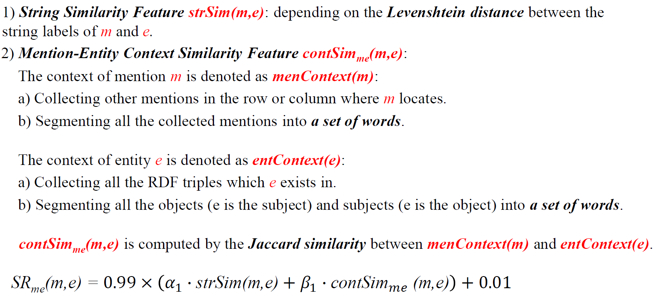

**Two features** are used to measure Entity Semantic Relatedness $SR_{ee}\left(e_{1},e_{2}\right)$ between entites and

1) 衡量两个实体是否在⼀个三元组

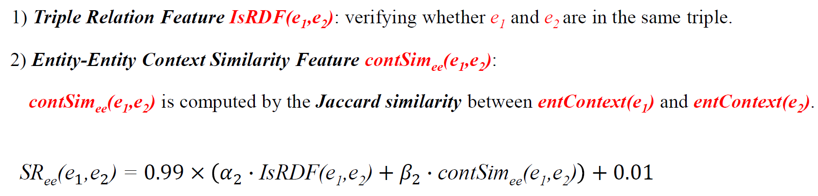

将上⾯的相关性分数作为消歧图中节点和边的初始概率分配，此时每个节点和边已经有了初步的概率估计，但是这些概率分配只考虑了局部影响,尚未充分结合整个图中节点之间的全局影响，所以需要采⽤Iterative Probability Propagation (迭代概率传播). 迭代概率传播⽤于为EL决策组合不同的EL影响因⼦。

对于有 $n$ 个节点的实体消歧图，定义 $n×n$ 的邻接矩阵， $A_{ij}$ 表示节点 i 和 j的规范化的语义相关度，定义 $n×1$ 的向量 $r$ 为每个节点的概率分配，使⽤迭代公式来重复计算更新 $r$,直到收敛，其中 $d$ 是常数， $E$ 是单位矩阵

$$r^{t+1}=\left(\left(1-d\right)×\frac{E}{n}+d×A\right)×r^{t}$$

**2. Column Typing**: Column to Class

**概念:** 实体链接完成之后，对于某⼀列的mention，如果都已经和数据库中的实体进⾏链接之后，可以根据上下的mention在数据库中实体的type推断该mention在数据库中实体的type（多数投票）



**3. Relation Extraction:** Semantic Association between Columns to Relation

**概念**:Relation extraction refers to the task of associating a pair of columns in a table with the relation that holds between their contents and /or extracting relationship information from tabular data and representing them in a structured format (e.g., as subject-predicate-object triples). 关系提取是指将表格中的a pair of列与它们内容之间的关系联系起来，或从表格数据中提取关系信息，并以结构化格式（如主题-谓词-对象三元组）表示出来。

实体链接完成之后，对于某两列的mention，如果都已经和数据库中的实体进⾏链接之后，并且这两列在数据库中很多都有相同的关系，那么可以补全缺失的关系(多数投票)

**Lecture 8 KGC: Knowledge Graph Construction from Semi-Structured Data**

**0. 什么是semi-structured data?**

Semi-structured data is a form of structured data that does not obey the tabular structure of data models associated with relational databases or other forms of data tables, but nonetheless contains tags or other markers to separate semantic elements and enforce hierarchies of records and fields within the data.半结构化数据是结构化数据的一种形式，它不遵从与关系数据库或其他形式数据表相关的数据模型的表格结构，但仍包含标签或其他标记，用于分隔语义元素，并对数据中的记录和字段进行分级。

**1. Modules of Knowledge Graph Construction from Online Encyclopedias**从在线百科全书构建知识图谱的模块

**-Fact Extraction事实提取**

**-Type Inference 类型推断**

**-Taxonomy Induction 分类归纳**

**2. Fact Extraction**

**概念:**Facts are factual knowledge represented as triples, each of which is in the form of <subject, predicate, object>

**subject**: an entity (an individual entity or a conceptual entity (i.e., concept))

**predicate**: property/ relation

**objec**t: an entity or a literal value

**分类:**

**A. Fact Extraction from Infoboxes:**Infobox有现成属性和属性值的键值对

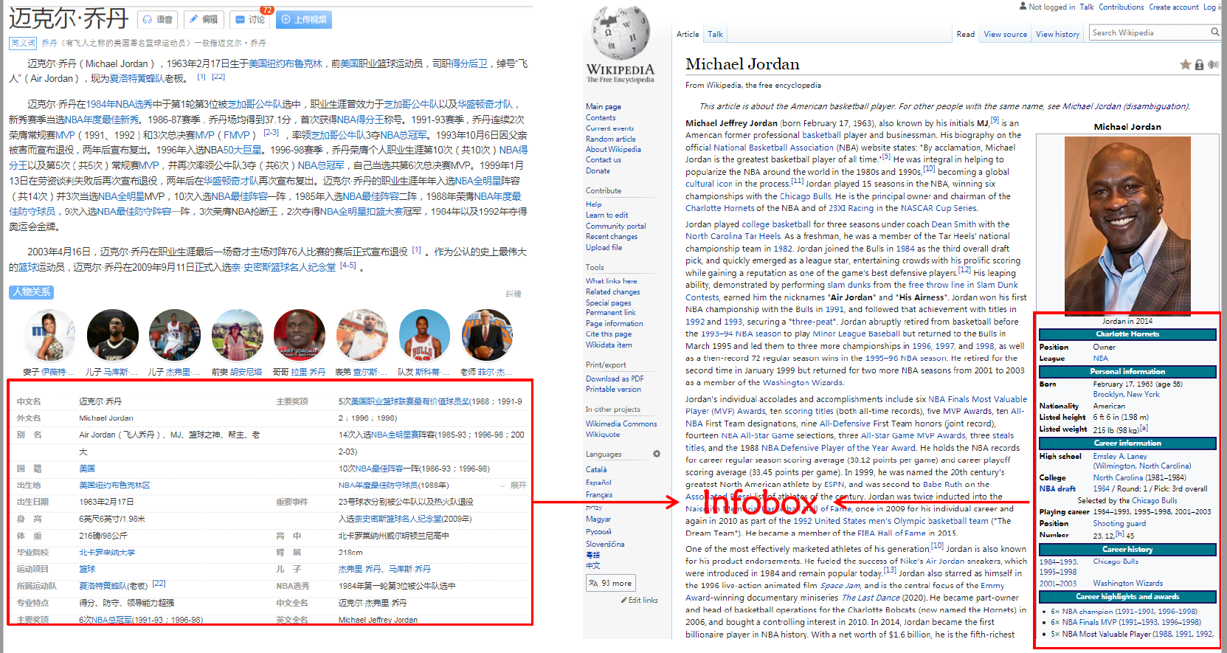

从下面这张图中

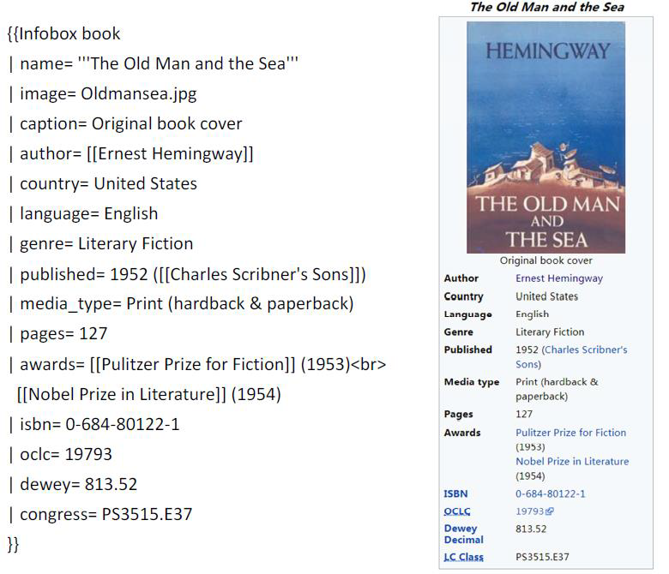

希望得到



**注意:** 其中的Literal形式需要声明datatype(^^后面的部分)

**B. Fact Extraction from Categories:使用Category map来抽取信息**

**-subject:** the **article entity** e.g.Qiang Yang

**-predicate:**the **target relation** e.g. birthOnDate

**-object:**the string captured by the brackets of **the regular expression** e.g.1964 births

一个示例的映射规则:



**注意: 在完成上述操作之后, Domain and Range checking是必须要做的事情, 检查domain和range的合法性**,逐个写:检查subject对应的entity是否在expp:hasWonPrize的定义域中, 检查xxx是否在expp:hasWonPrize的值域中…每个都写一遍

**3. Type Inference---类型推断**

**概念:** One of the most valuable kinds of knowledge is type information , which refers to the axioms stating that an instance is of a certain type.

最有价值的知识之一是类型信息，它是指说明实例属于某种类型的公理

**应用:** Semantic Search, Product Search/Recommendation,

**示例:** 知识图谱的Schema层和Instance层通过Type连接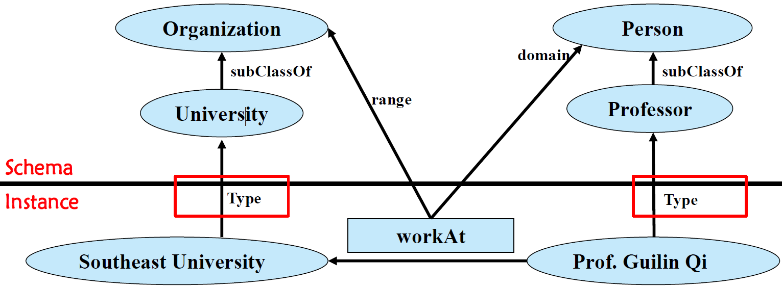

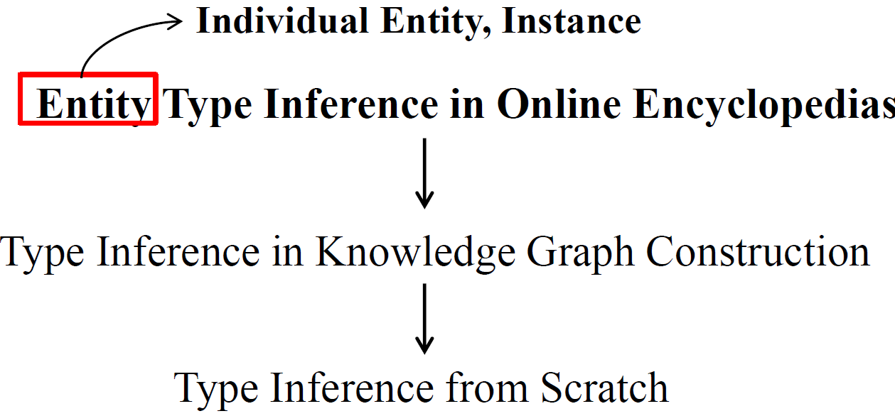

**类型**:

**A. Type Inference from Infoboxes**

1) Names of infobox templates are extracted as entity types ( DBpedia). 1) 信息框模板的名称将被提取为实体类型（DBpedia）

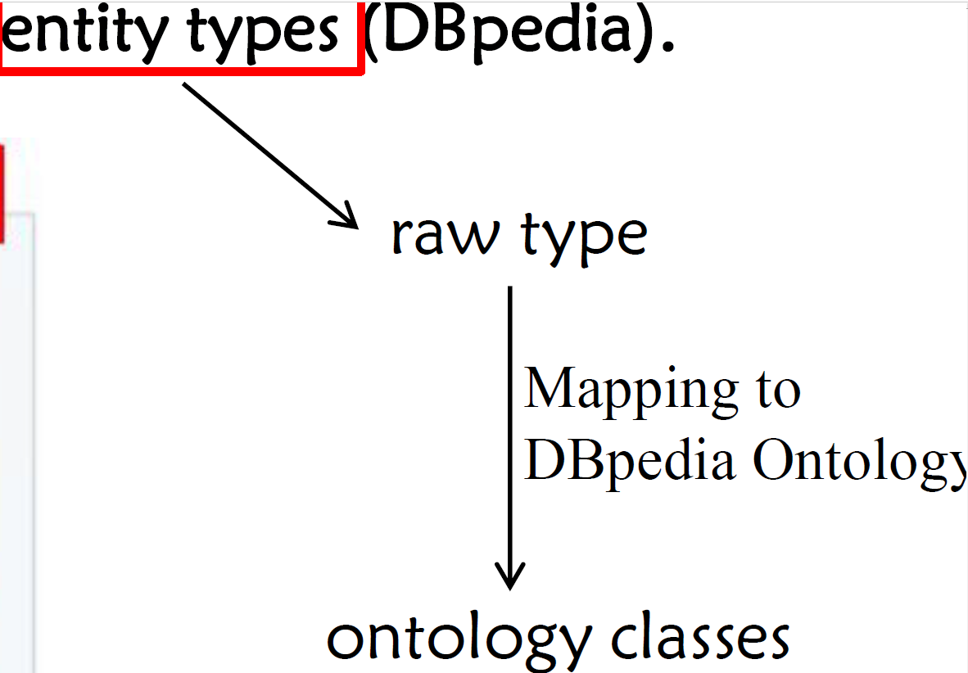

2)Property value pairs in infoboxes are mapped to concept instance pairs (Zhishi.me). 信息框中的**属性-值对**被映射为**概念-实例**对

-Each **article** in the online encyclopedia is taken as an **instance** , so all articles form an instance set

- Each **category** (i.e., article category) in the online encyclopedia is treated as a **concept (i.e., class)**, so all categories compose a concept/class set

- In the infobox of each article, a set of **property value pairs** can be extracted as $PV=<p_{1},v_{1}>,…,<p_{k},v_{k}>.$ 对于某⼀个infobox每⼀个属性-属性值对 $<p_{k},v_{k}>$,如果 $p_{k}∈C,v_{k}∈I,$ 那么 $v_{k} \text{rdf:type} p_{k}$

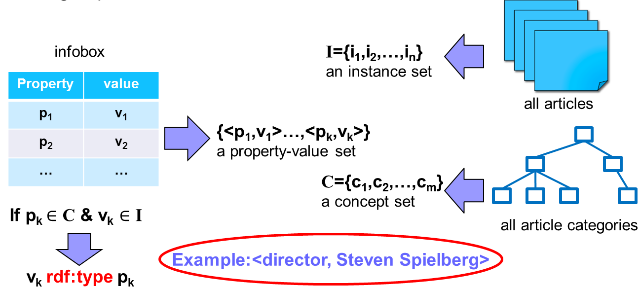

在线百科全书中，每篇文章通常被归入**多个类别**，因此 这些类别可以作为实体/实例的**重要候选类型**, 需要过滤之后才能把其视为真正的type

YAGO 将所有类别分为概念类别（实际上是实体类型）和非概念类别。

- ⾸先将每⼀个category(e.g. Naturalized citizens of Germany)拆成 a pre-modifier (Naturalized), a head (citizens) and a post-modifier (Germany)

- 如果head不是缩写，并且是复数，那么给定的类别是候选概念类别；

- 对于每个候选概念类别，如果它包含⼀个⾮概念词（由 YAGO总结的），那么它就可以成为⼀个administrative category或者 a relational category或者 a thematic category

**YAGO方式应用到Type Inference存在的问题**

**1).** 对于没有明显单数、复数形式的名词的语⾔⽆法运⽤(如中文和日文)

**2).** 没有真正捕捉实例和类之间的语义关联，这可能会导致类型推断过程中的错误**。**

**B. Type Inference from Text**

**步骤:**

**1) Type extraction ,** which extracts the types of each entity from the first sentence of its corresponding article. 类型提取，从对应文章的首句中提取每个实体的类型。每篇⽂章的第⼀句给出了每个实体的⽂本定义，它通常提供重要的类型信息。

**2) Type disambiguation,** which links extracted types to correct Wikipedia entities. 类型消歧,由于第⼀步中提取的类型只是普通字符串，第⼆步旨在为这些类型分配真正的意义。

**方法:**

**Type inference with a lightweight Syntactic Pattern: Type Extraction**

LHD directly applies a simple syntactic pattern as follows



即 A isa B, where A is a sequence of any tokens, and B denotes candidate types.

仅使用模式来提取实体类型虽然有效，但精度无法保证,⽐如会出现only the first type is extracted, 有部分⽂章被排除了, 对于multi-word type，仅仅提取到最后⼀个词，跳过位于更具体类型之前的通⽤泛型类型，提取出的结果不是词根。因此，我们提出了几种启发式方法来提高提取质量。



LHD的Type Disambiguation使⽤Search Linker，This linker以提取的类型为输⼊，并利⽤维基百科搜索API1返回消歧义的维基百科⽂章。

**4. Taxonomy Induction---构建类别之间的层次关系**

**概念**: A taxonomy is a directed acyclic graph consisting of is a relations between entities, including conceptual entities and individual entities分类法是一种**有向无循环图**，它的边具有is-a的关系，如果是class之间就是subclass，如果是instance和class之间就是rdf:type, 由实体（包括概念实体和单个实体）之间的关系组成

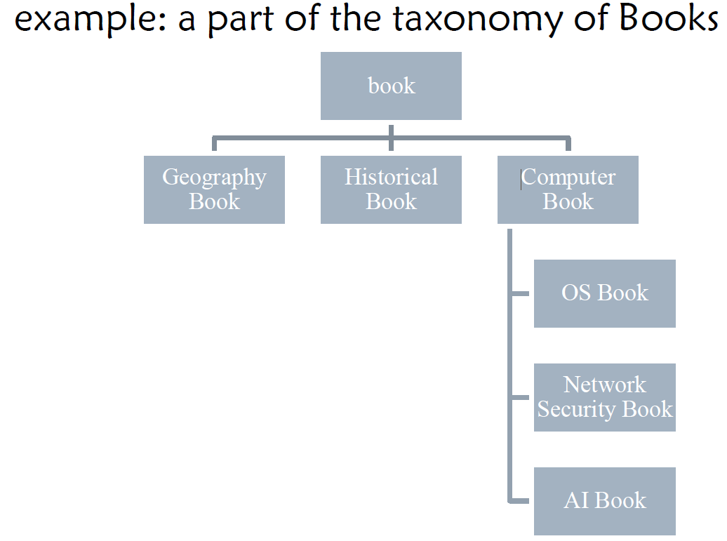

在这里，分类归纳法是从在线百科全书中归纳出分类法。

维基百科有⾃⼰的分类系统，但类别并不构成⼀个具有成熟的层次分类体，因此它只是⼀个主题组织的词库。

来⾃维基百科的层次分类体系是通过删除not-is-a关系来完善维基百科类别系统。

**步骤**:

**The first step Pre-Cleaning:**

-删除用于维基百科管理的类别，即删除标签包含以下任何字符串的类别：*wikipedia, wikiprojects , lists , mediawiki , template, user, portal, categories, articles , and pages.*

-维基百科使用Pattern来组织许多类别对：Y X and X by Z

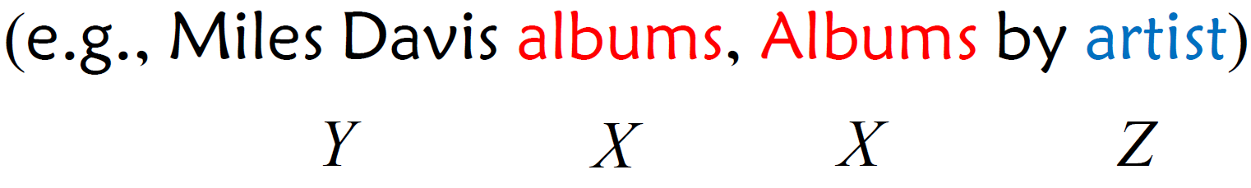

-这些类别之间的关系定义为 is-refined-by ，这是为了更好地构建和简化分类系统，应予以删除。

**The second step - Syntax based Method:**

-如果一对类别共用一个词头(lexical head)，那么这两个类别之间就存在is-a关系.e.g. *British Computer Scientists is-a Computer Scientists*

- 如果其中一个词类的词头(lexical head)出现在另一个词类的非词头位置，那么这些词类之间就标注了 not-is-a 关系 e.g. Crime comics not-is-a Crime

**The third step - Connectivity based Method:**

对于⼀个类别c，如果能找到⼀篇⽂章名字也是这个类别，那么对于找到的⽂章，搜集⽂章的词汇中⼼词为复数的categories为集合caSet，在category system中找到c的super category上位词sc，如果sc的词

汇中⼼词和caSet中⾄少⼀个category的词汇中⼼词⼀样，那么这个is-a关系成⽴

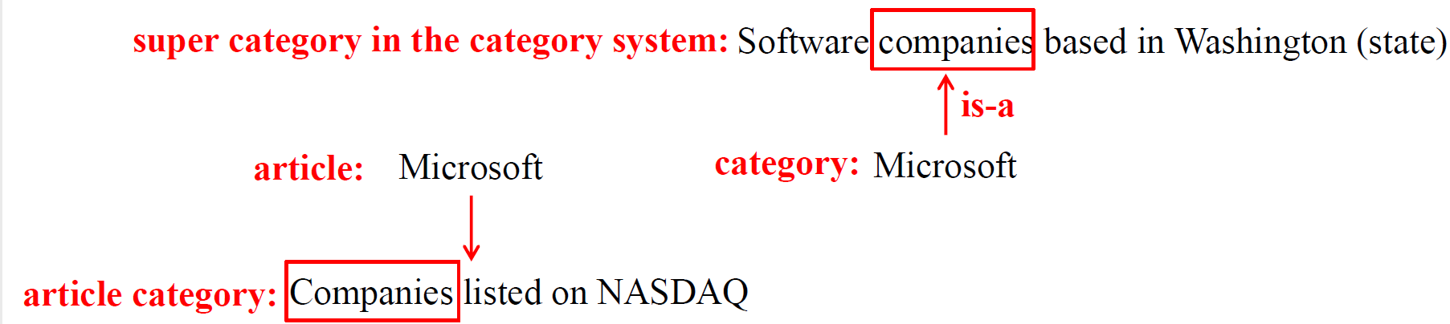

**The fourth step - Lexico Syntactic based Method:**

词法句法模式可用于从大规模语料库（如维基百科中的所有文章）中识别类别之间的is-a 和not-is-a关系**。**

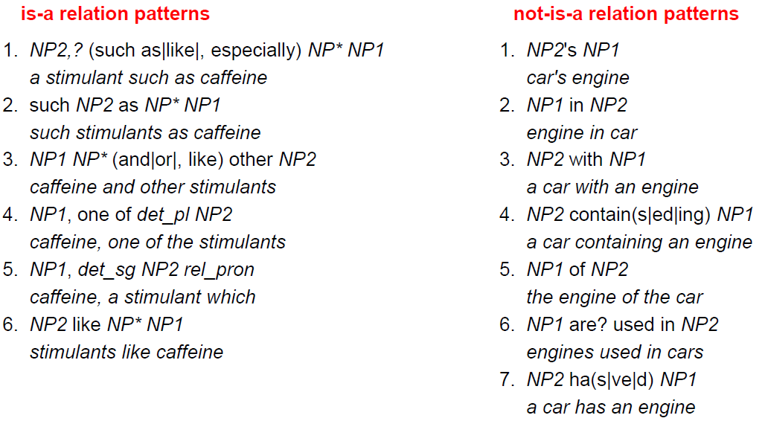

**The fifth step Inference based Method:**

**-**propagate the previously found relations based on the properties of transitivity of the is-a relation 根据 is-a 关系的反式属性，推广之前找到的关系

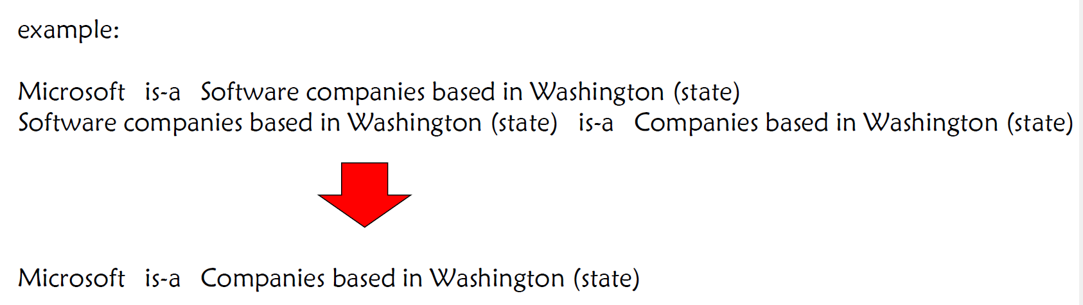

**Lecture 9 KGC: Knowledge Graph Construction from Unstructured data**

**0. Knowledge Graph Construction from Unstructured Data (Text)** 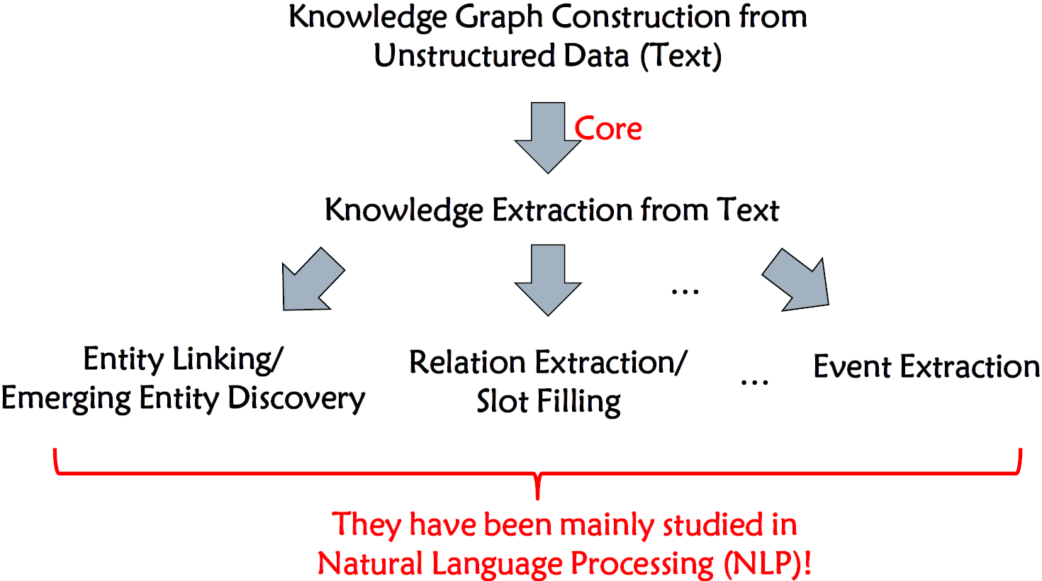

**1. Two Specific Tasks in Knowledge Engineering**

**分类:**

**A. General IS-A Relation Extraction(有助于建立分类标准）**

**B. Terminology/ Term Extraction特定领域知识图谱构建**

**2. General IS-A Relation Extraction**

一般的 is-a 关系是更具体的词（即hyponym, e.g., daisy and rose）与更一般的术语（即hypernym, e.g., flower）之间的语义关系。

**Feature of is-a relations:**

**-Transitivity传递性:** A is-a B, B is-a C $→$ A is-a C

- **Asymmetry** **非对称性**: A is-a B $↛$ B is-a A

**任务描述:**

**-Triple g eneration:**输入:一个大规模语料库; 输出:表示is-a relations的三元组

-**IS-A relation prediction**: 输入: 一对候选的下位词和上位词，以及相应的向量表示 输出: True or False

**方法分类:**

**-Pattern based Methods** (task: triple generation): Hearst Patterns



**- Distributional Methods (**task : is-a relation prediction**):**

**Why Introducing Distributional Methods?**

**-Limitations of Pattern based Methods:** 因为要求上下位词必须同时现在同⼀句话⾥，所以coverage和generalization是不确定的

-Distributional Methods aim to solve the problem of co-occurrence sparsity between the hyponym and hypernym 旨在解决上下位词之间同时出现稀疏的问题

**- 分布方法**是根据术语的分布表示（即向量），通过无监督措施或有监督模型来预测术语之间的关系。

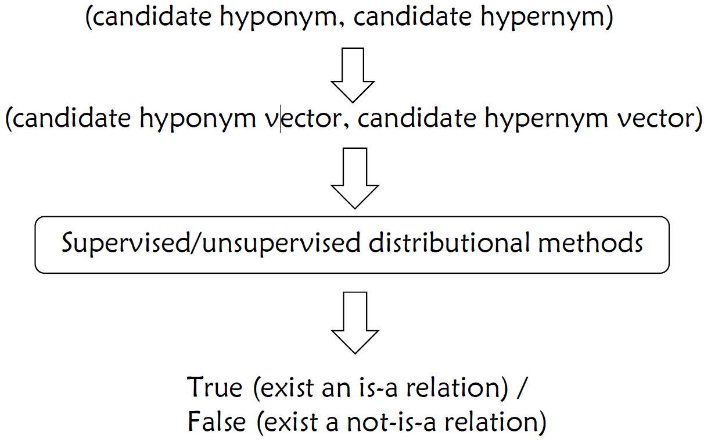

**- Unsupervised Distributional Methods**

**A Classic Asymmetric Distributional Similarity Measure: WeedsPrec**

它捕捉了 u 的特征，这些特征包含在范围更广的术语 v 的特征集合中**。**

$$WeedsPrec(u→v)=\frac{\sum_{f∈F_{u}∩F_{v}}{ }W_{u}(f)}{\sum_{f∈F_{u}}{ }W_{u}(f)}$$

对每个term $u$, $v$ 是候选上位词; $f$ 表示同时与 $u$ 出现在上下文的一个单词, $F_{u}$

是所有 $f$ 的集合, $W_{u}\left(f\right)$ 计算 $u,f$ 之间的统计关系,比如 $PMI\left(u,f\right)$

$$PMI(w,c)=log⁡\frac{p(w,c)}{p(w)p(c)}$$

$p\left(∙\right)$ 表示句子中出现 $∙$ 的频率=出现了的句子数量/总句子数量

**- Supervised Distributional Methods**

Project learning 学习⼀个函数来衡量两个单词之间存在is-a关系的可能性。

A projection tensor $T$ ⽤于将将下位词向量投影到上位词向量。

输入一个query $q$ 和一个候选的hypernym上位词 $h$,输出 $pair\left(q,h\right)$ 为is-a关系的可能性.

首先查询 $q,h$ 的词向量,计算相似度 $s=q^{T}T_{i}h,y=F\left(s\right)$, $F$ 是个全连接层.

**How to Get Distributional Representations?**

-Pre-trained Models on a Corpus.

-Traditional Methods based on Term Co-Occurrence .

Example: sliding window strategy

**4. Terminology/ Term Extraction**

**Terminology(domain-relevant ):** Linguistic units which characterise specialised domains作为专业领域特征的语⾔单位，有利于去构建特定领域的知识图谱.

**Terminology Extraction:**

-Terminology extraction is associated with some other tasks, such as NER , keyword extraction, etc. 术语提取与其他一些任务相关，如 NER、关键词提取等。

-与其他任务不同，术语提取与领域高度相关。

- 术语提取是本体构建、文本摘要、知识图谱等方面的关键问题。

**Framework:**

A. Input Text:

B. Preprocessing:

-Tokenization: Tokenization describes splitting paragraphs into sentences, or sentences into individual words.

- Cleaning: Word like “the” or “and” can be removed by comparing text to a list of stopword.

- POS: Part of Speech (POS) often requires looking at the proceeding and following words and combined with either a rule-based or stochastic method 打上词性标注

- Stemming: Stemming is a process, 通过删除不必要的字符（通常是后缀）来消除词形变化，从⽽将单

词简化为词根

- Lemmazation: 词形还原 主要是把单词的词缀部分除去，从⽽得到单词的词⼲部分

C. Terminology Extraction

D. Filtering

-Common Dictionary Filtering 如果候选术语出现在常⻅的中⽂词典中：删除候选术语

-Irregular Filtering(Filter irregular words) 对于候选⼈列表中的每个候选⼈术语，计算语料库中出现的字符串的频率：

**Linguistic-based approaches Chunker**

**理论：**语料库中提取的术语中有90%以上是名词短语NP(Noun Phrases)

**步骤：A.** 使⽤词性和正则表达式来定义NP的组成模式(Define patterns of NPs)称为NPChunker **B.** 对句⼦中的词进⾏词性标注，使⽤NPChunker来构建句法树，得到为NP的候选术语(Find Candidate Terms using Chunker) **C.** 候选术语过滤(Candidate Terms Filtering)

**Statistical-based approaches--TF-IDF**

$$w_{t,d}={tf}_{t,d}×{idf}_{t}$$

$$tf_{t,d}=\frac{\text{Number of certain word in a document}}{\text{Number of all words in a document}}$$

$$idf_{t}=\log{\frac{\text{Number of all documents in corpus}}{\text{Number of documents cotaining the certain word }t+1}}$$

tf-idf矩阵横着看是单词的表示，纵向来看是⽂档的表示

PMI⽅法参⻅Construction from Unstructured Data的Distributional Methods

**Graph-based approaches**

**概念:** constructing graph based on the co-occurrence relationship between words

**方法代表:**

**A. PageRank**

Regard the Internet as a directed graph, with webpages as nodes in the graph and links between webpages

as edges in the graph. 将互联⽹视为有向图形，⽹⻚作为图形中的节点，⽹⻚之间的链接作为图形中的边缘。当⼀个⽹⻚被许多其他⽹⻚链接时，这意味着这个⽹⻚更重要，也就是说，这个⽹⻚的PR值（PageRank值）会更⾼。如果具有⾼PR值的⽹⻚链接到另⼀个⽹⻚，则链接⽹⻚的PR值将相应增加。

⽹⻚ $i$ 的PageRank score: $PR\left(i\right)=\sum_{j∈B_{i}}{ }\frac{PR\left(j\right)}{out\left(j\right)}$ 其中 $B_{i}$ 是链接到 $i$ 的收集到的⽹⻚集合, $out(j)$ 是⽹⻚的出度 $j$ 上述公式假设⽤户只单击当前⽹⻚的链接来浏览下⼀个⽹⻚，但随机浏览⽅法更符合实际情况。因此，⽣成随机浏

览模型，随机浏览模型中每个⽹⻚的PR值由以下公式计算： $PR(i)=(1-d)+d×\sum_{j∈B_{i}}{ }\frac{PR(j)}{out(j)},$ PR初始化为1/N，N为⽹⻚总数，1-d为浏览者随机点开的概率，d⼀般取0.85

**B.TextRank 网页变成了词**

a. 输⼊⽂本 b. 预处理(分词) c. 构建图，节点是词，两个节点之间如果存在边缘，则它们的相应单词共同出现在⻓度为K的窗⼝中 d. 根据公式迭代计算每个节点的权重，直到收敛.

**Lecture 11: Knowledge Graph Alignment**

**0. Why do we need Knowledge Graph Alignment?**

-Knowledge graph construction needs to fuse the data from multiple sources! 知识图谱的构建需要融合多种来源的数据.

- Identifying the same entity with different descriptions from multiple sources is the key of knowledge graph alignment! 从多个来源的不同描述中识别同一实体是知识图谱对齐的关键

**概念:** Knowledge graph alignment identifies relationships between classes (subClassOf and etc,) properties (equivalence, subPropertyOf and etc.) and instances (sameAs) 知识图谱对齐可识别类（subClassOf 等）、属性（等价、subPropertyOf 等）和实例（sameAs）之间的关系

**包括: ontology matching (i.e., schema matching)本体匹配和instance matching实例匹配**

**1. Ontology Matching**

**概念:** It is the process of finding correspondences (i.e., relationships) between classes (or properties) of different ontologies它是在不同本体的类（或属性）之间寻找对应关系（即关系）的过程

**好处:**

-从局部本体创建全局本体

-在本体之间重复使用信息

-处理异质性

-跨多个分布式资源的查询

**过程**: 匹配过程可视为一个函数 $f$，它从一对要匹配的本体 $o$ 和 $o^{''}$,一个输入alignment $A$ (初始的已知的对齐)、一组参数 $p$ (weight, threshold等)和一组资源 $r$ 出发，返回这些本体之间的Alignment $A'$ (对齐结果)： $A^{'}=f(o,o^{'},A,p,r)$

**技术:**

**A.** **Element-level matching techniques:** 单独的去分析entity或者instance，忽略他们与其他的entity或 instance的关系

**a. Language-based**

**prefix**: takes as input two strings and checks whether the first string starts with the second one

net = network; but also hot=hotel

**suffix**: takes as input two strings and checks whether the first string ends with the second one

ID = PID; but also word = sword

**Edit distance**(Levenshtein distance) 参⻅Entity Linking的Candidate Generation部分,由最长字符串的长度进行归一化

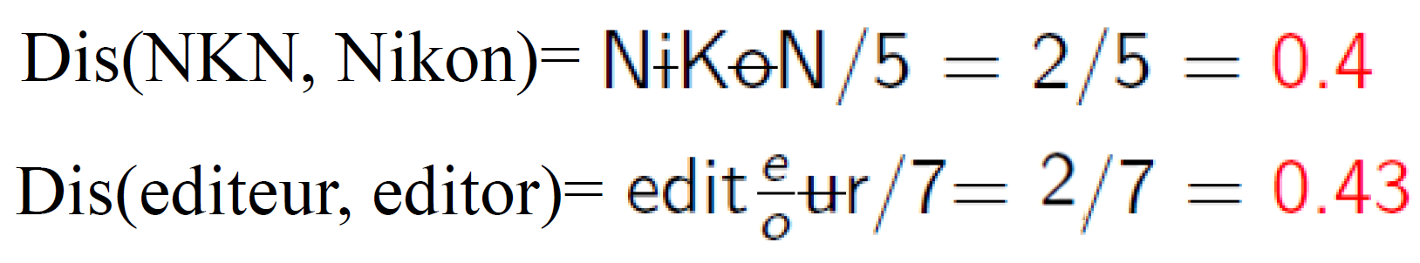

**n-gram** 参⻅Entity Linking的Candidate Generation部分(字符级别), 由最长字符串的长度进行归一化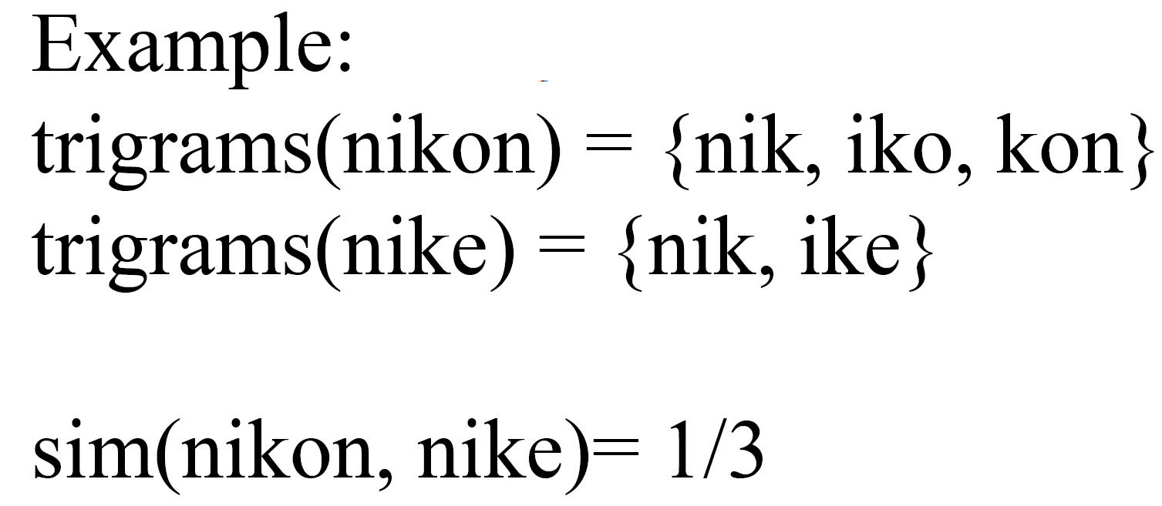

**Tokenization**: parses names intio tokens by recognizing punctuation, cases

Hands-Free_Kits -> <hands, free, kits>

**Lemmatization**

Kits->kit

**Elimination:** discards "empty" tokens that are articles, prepositions, conjunctions, etc.e.g. a, the, by, from

**b. Resource-based**



**B. Structure-level techniques:** 从结构的⻆度来分析entity或者instance

**a. Graph based Techniques**:

-consider the input ontologies as labeled graphs;

- if two nodes from two ontologies are similar , their neighbors may also be

somehow similar( similar subclasses, superclasses , and properties)

**b. Taxonomy based Techniques:**

- are also graph algorithms which consider only is a relations between classes**;** 也是只考虑类之间关系的图算法**；**

- is-a links connect terms that are already similar, therefore their neighbors may be somehow similar. is-a 链接将已经相似的术语连接起来，因此它们的邻接词也可能在某种程度上相似。

**c. Model based Techniques**

- handle the input ontologies based on its semantic interpretation ( e.g ,model theoretic semantics);

- if two classes (or properties) are the same, then they share the same interpretation.

**d. Instance based Techniques:**

**-**compare sets of instances of classes to decide if these classes match or not (i.e., exist equivalence or subClassOf relations). 需要设计⾮对称的相似度特征，因为本体匹配在类和属性上都有⾮对称的关系需要去识别(⽐如subClassOf)

**2. Matcher Composition匹配器构成:**

**A. Sequential compositions of matchers**

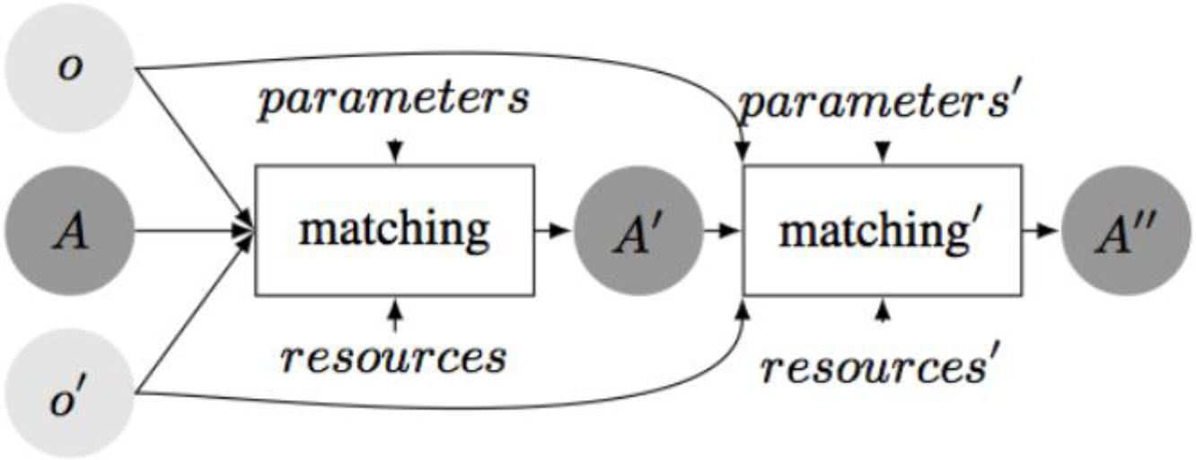

**Problem:** 误差累积和较差的收敛性.

**B. Parallel composition of matchers:** 可以用很多的相似度度量来做



A pair of candidate matched classes is denoted as ($C_{1k},C_{2P}$), and note that ($C_{1k},C_{2P}$) is a **different** pair since we need to measure the asymmetric similarities between classes

**a. String Similarity: $CLsim(C_{1k},C_{2p})=\frac{LCS(l(C_{1k}),l(C_{2p}))}{\left|l(C_{1k})\right|}$** , where LCS means the length of the longest common substring, $l(∙)$ returns the label of the class, and $| ∙ |$ returns the length of the input label.

**b. Neighbor Class Set Similarity: $NCSsim=\frac{\left|NCS\left(C_{1k}\right)∩NCS\left(C_{2p}\right)\right|}{\left|NCS\left(C_{1k}\right)\right|}$** , $NCS(∙)$

返回the set of first-order neighbor classes in the given ontology.

**c. Textual Context Similarity: $TCsim\left(C_{1k},C_{2p}\right)=\frac{\sum_{v=1}^{n}{ }TC(C_{1k})_{v}⋅TC(C_{2p})_{v}}{\sum_{v=1}^{n}{ }TC(C_{1k})_{v}^{2}}$**,其中 $TC{\left(C_{1k}\right)}_{v}$ 是表示class $C_{1k}$ 的第v个值,向量长度为n

**d. Instance Set Similarity $ISsim(C_{1k},C_{2p})=\frac{|IS(C_{1k})∩IS(C_{2p})|}{|IS(C_{1k})|},$ $IS\left(C_{1k}\right)$** 返回 $C_{1k}$ 的instance set  
**Element-level matching techniques**: String Similarity, Textual Context Similarity

**Structure-level Matching Techniques**: Neighbor Class Set Similarity, Instance Set Similarity

**3. Instance Matching**

**概念:** It is the process of finding different instances of the

same real-world objects.(sameAs关系)

**方法**:

**A. 基于知识图谱嵌入的方法**:可扩展性强,能处理大规模数据;自动学习特征,不需要手动设计规则,能捕获隐含的语义关系, 对噪声有容忍度. 准确性稍差, 缺乏可解释性,计算成本高,在测试前需要大量训练数据

B. 基于规则的方法:依赖于本身数据源的质量,结果可解释性强,不需要训练数据,计算效率高,可以整合先验知识;规则设计困难,扩展性差,难以处理复杂情况;

**Lecture 12 13 14 KGQ:Knowledge Graph Querying**

**0. SPARQL is an RDF query language** , that is, a semantic query language for databases, able to retrieve and manipulate data stored in RDF format

**How to get information from RDF graphs by SPARQL?**

**-Pattern matching**

**Pattern:** describe subgraphs of the queried RDF graph

**Matching:** match the pattern to the s ubgraphs to contribute an answer

B**uilding blocks:** graph patterns

(i.e. RDF graphs with variables)

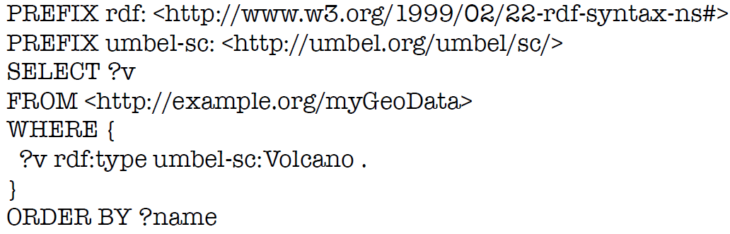

**1. Components of SPARQL Queries**

**A . Prologue: Prefix definitions** for compact URIs; **Attention** (difference w.r.t. Turtle ): No period (“.”) character as separator.

**B. Query Form:** SELECT, DESCRIBE, CONSTRUCT or ASK

**C . Dataset specification:** Specify the RDF dataset to be querying

**D .** **Query pattern:** WHERE clause specifies the graph pattern to be matched

**E. Solution modifiers:**

**-Order :** put the solutions in order;

**-Projection:** choose certain variables;

**-Distinct:** ensure solutions in the sequence are unique**;**

**-Reduced:** permit elimination of some non unique solutions;

**-Offset:** control where the solutions start from in the overall sequence of **solutions;**

**-Limit:** restrict the number of solutions.

**2. Graph Patterns**

**Different types** of graph patterns for the query pattern (WHERE clause):

**A. Basic Graph Patterns,** where a set of triple patterns must match;

Triple patterns are similar to RDF triples, but **any component can be a query variable.**

**Matching a triple pattern to a graph:** bindings between variables and RDF terms.

**Matching of basic graph patterns:** A Pattern Solution of Graph Pattern GP on graph G is any substitution S such that S(GP) is a subgraph of G.

WHERE从句中加多个BGP,默认它们之间关系为与.

FILTER(<筛选条件,满足的被保留>)关键字对pattern结果进行进一步筛选

**Matching RDF literals**:a. 没有指定language tag和指定了language tag的字符串不能同等对待,不匹配.b. 数值可以跨类型匹配(数值类型间可能存在隐式转换,如数字42=字符串42=”0042”)c. 自定义数据类型需要精确匹配(带上^^dt:customizedType) d. 特殊函数str(?literal)忽略语言标签和数据类型, LANG(?literal)检查语言标签,DATATYPE(?literal)检查数据类型, regex(?name,”Smith”),对变量进行正则匹配

**B.Group Graph Pattern**, where a set of graph patterns must all match;

**C.Optional Graph patterns**, where additional patterns may extend the solution;

如果可选部分不匹配，则不会创建绑定，但也不会消除解决方案。(Query results中出现”空”时考虑, 以及筛选”不在某个位置的火山”)

Constraints in Optional Pattern Matching

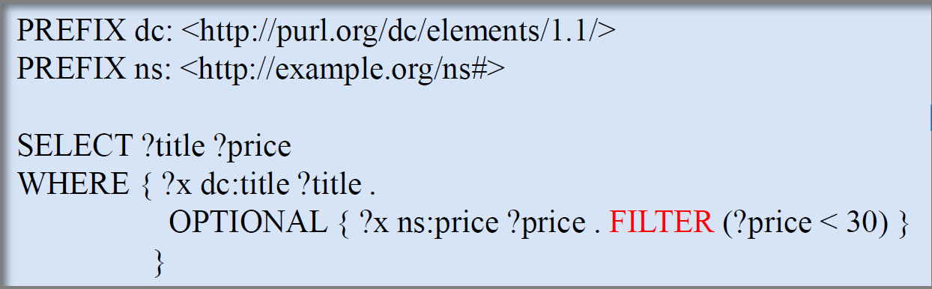

**D. Alternative (Union) Graph Pattern,** where two or more possible patterns are tried; 没有UNION，句⼦之间是且的关系，有了UNION，是或的关系

**2.Dataset specification**

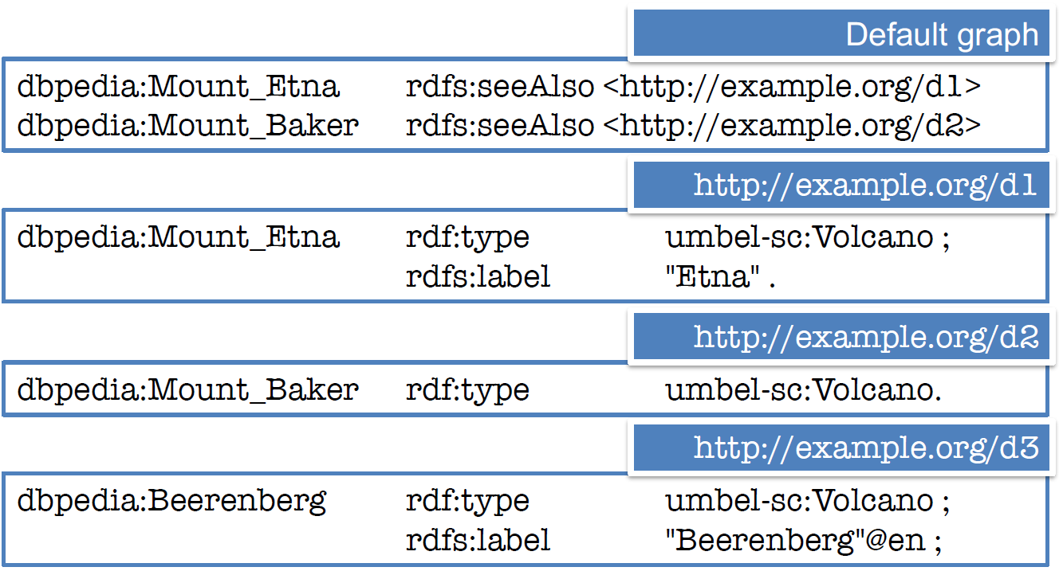

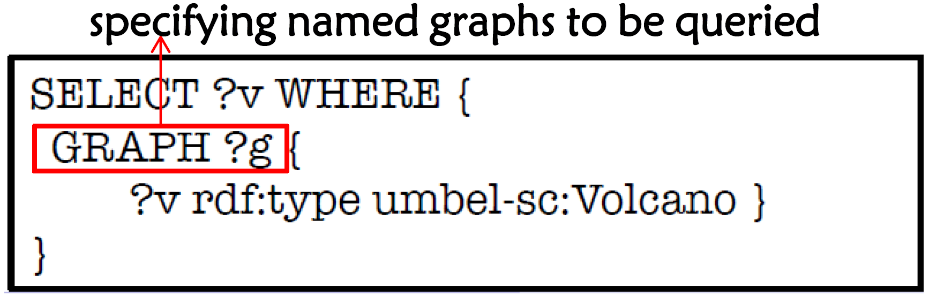

初始阶段默认查询default graph, GRAPH⼦句⽤来让⼀个named graph成为active graph来被查询.

**3. Query Forms**

**A .SELECT:** 结果是所有solution的序列, Selected variables separated by space (not by comma!); Asterisk character (“*”) selects all variables in the pattern.

**B. CONSTRUCT:** 结果是从模版构建的一个RDF graph,模版指的是与query pattern 匹配的变量.

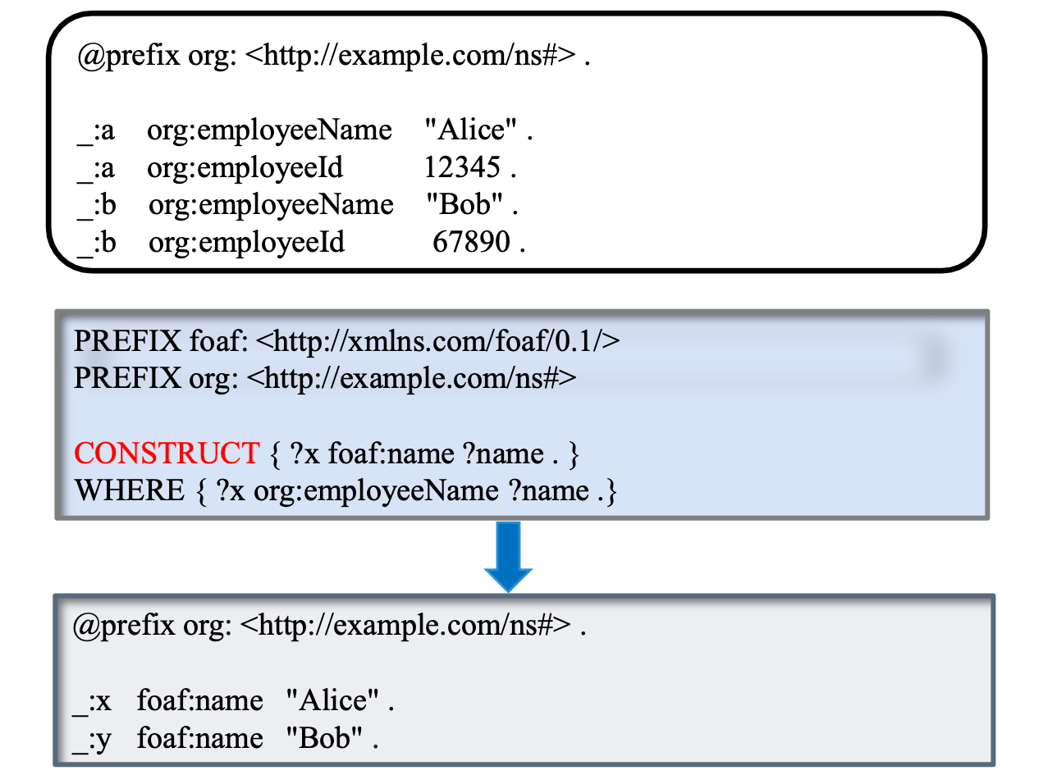

**C. ASK:** 检查是否至少有一个结果满足ASK中的pattern,返回True or False.

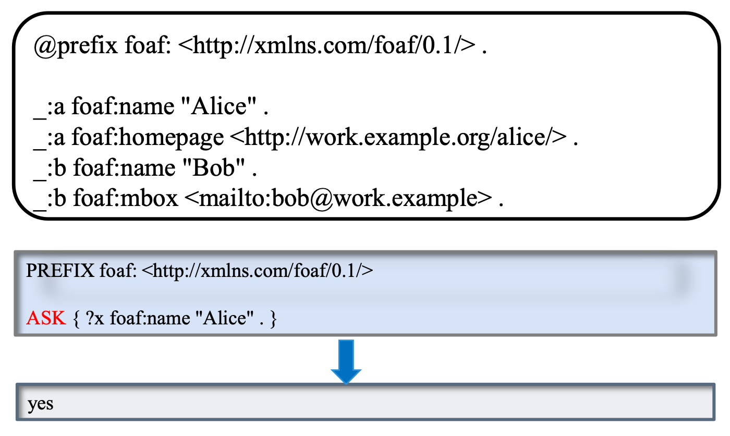

**D .DESCRIBE:**结果是包含匹配到的资源的相关的所有的三元组



**E.INSERT** 插入新的RDF三元组到现有的RDF graph中

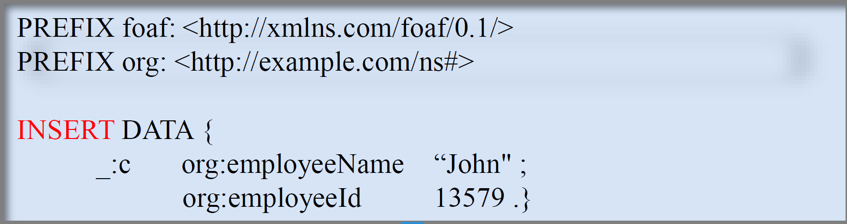

**F. DELETE** 从RDF graph中删除一些三元组

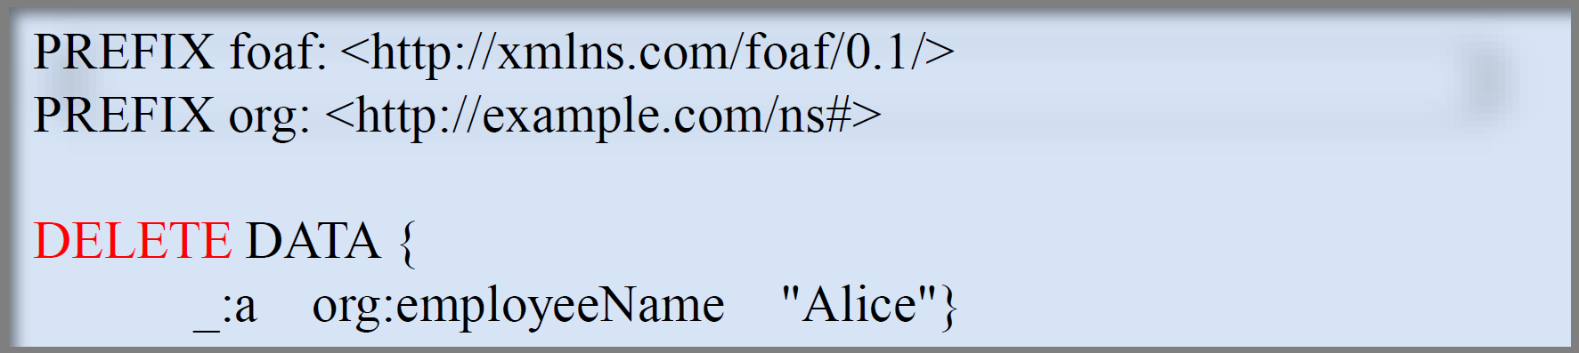

**G. DELETE/INSERT** 配合WHERE Clause

**4.Solution Modifiers**

只有SELECT queries才能用, 将结果作为一个整体进行修改,而非对单个solution

**A.DISTINCT** 从查询到的结果中删除重复元素.



**B. ORDER BY** 对结果进行排序



**C.LIMIT**

**D. OFFSET** 这两个都与ORDER BY配合使用

**5. Others: BINDINGS**在**WHERE Clause**中写BIND (?p-?r) AS ?price或者在**SELECT**后写SELECT (?p-?r) AS ?price

**6.Cypher**

**概念:** Cypher is a declarative graph query language that allows for expressive and efficient querying, updating and administering of the graph.

**注意:**Cypher语言的关键词不是大小写敏感的

**7. Cypher -Create**

**A. Create a node**

**CREATE (<node-name>:<label-name>**

**{**

<Property1-name>:<Property1-Value>

........

<Propertyn-name>:<Propertyn-Value>

**})**

**B. Create relationships**

**CREATE**

**(<node1-name>:<node1-label-name>{<define-properties-list>})**

**-[<relationship-name>:<relationship-label-name>{<define-properties-list>}]**

**->(<node2-name>:<node2-label-name>{<define-properties-list>})**

**8.Cypher-MATCH**

**MATCH**

**(<node-name>:<label-name>**

**{**

<Property1-name>:<Property1-Value>

........

<Propertyn-name>:<Propertyn-Value>

**})**

**-[**<relationship-name>:<relationship-label-name>{<define-properties-list>}**]**

**->(<node-name>:<label-name>**

{

<Property1-name>:<Property1-Value>

........

<Propertyn-name>:<Propertyn-Value>

}**)**

**RETURN ........**

**A. Match node**

-查询所有节点: Match (n) RETURN n;

-查询所有电影title: Match(movie:Movie) RETURN movie.title

**B. Match related nodes**查询名叫Oliver Stone相关联的事物标题:

MATCH (director {name: 'Oliver Stone'})--(movie)

RETURN movie.title

**-- : connected relationship of unknown relationship type and direction**

带上label的话就可以**限定事物类型**

**C. Match relations**

**-**查询与人物Oliver Stone相关联的关系类型

MATCH (:Person {name: 'Oliver Stone'})-[r]->(movie)

RETURN type(r)

**-> / <- : directed relation, > towards the tail entity**

**D. Match on relationship type**

MATCH (wallstreet:Movie {title: 'Wall Street'})<-[:ACTED_IN]-(actor)

RETURN actor.name

**在多种关系类型上查询:** 关系类型之间用|隔开,通过变量r可以绑定到被查询的关系.

**E. Match and Create:** when nodes already exist, we can use MATCH first, then CREATE

MATCH

(charlie:Person {name: 'Charlie Sheen'}),

(rob:Person {name: 'Rob Reiner'})

CREATE

(rob)-[:`TYPE INCLUDING A SPACE`]->(charlie)

**9. Cypher-DELETE**

**A .** **Delete single node:** **删除名为UNKNOWN的节点**

MATCH (n:Person {name: 'UNKNOWN’}) DELETE n

B . Delete all nodes and relationships: 删除数据库中所有节点及与其相连的关系: MATCH (n) DETACH DELETE n

**C. Delete a node with all its relationships**删除名为Andy的节点和与其相连的所有关系: MATCH (n {name: 'Andy’}) DETACH DELETE n

**D. Delete relationships only:** 删除Andy的所有KNOWS关系

MATCH (n {name: 'Andy'})-[r:KNOWS]->() DELETE r

**9. Cypher-UPDATE**

**SET:** SET can be used with a map — provided as a literal, a parameter, or a node or relationship — to set properties**.**

**A. Update a property**

MATCH (n {name: 'Andy'})

SET n.age = toString(n.age)

RETURN n.name, n.age

**B. multiple properties using one SET clause**

MATCH (n {name: 'Andy'})

SET n.position = 'Developer', n.surname = 'Taylor'

**C. Replace all properties using a map**

MATCH (p {name: 'Peter'})

SET p = {name: 'Peter Smith’,

position: 'Entrepreneur'}

RETURN p.name, p.age, p.position